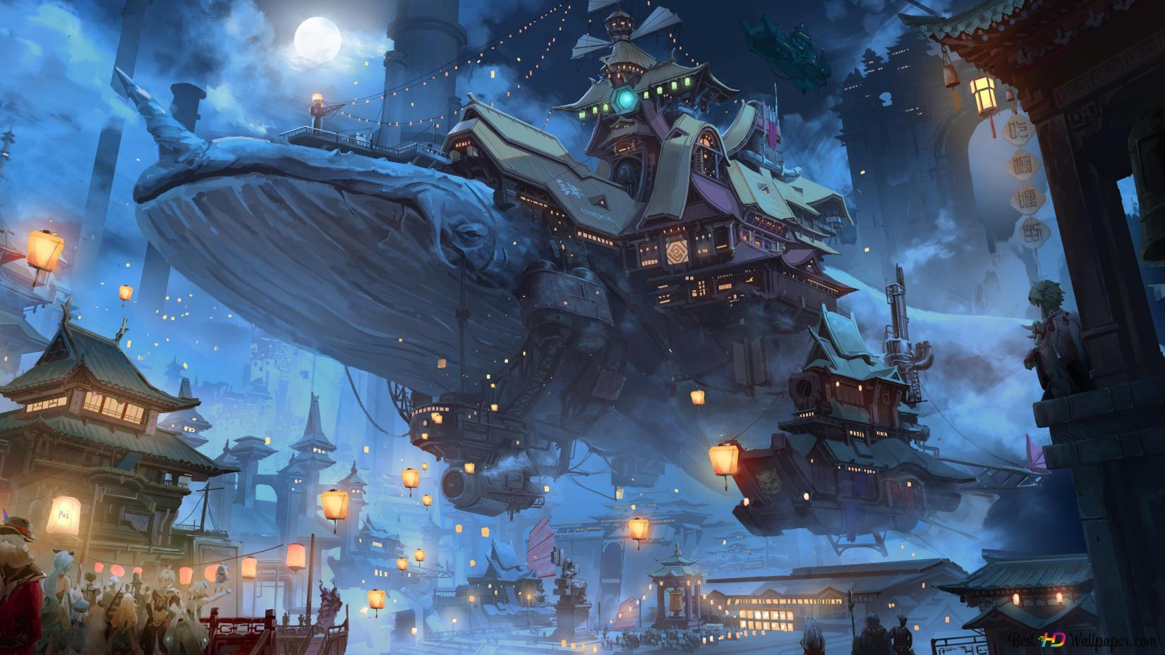

**Knowledge Representation and Reasoning**

**Project Report**

**Genshin Impact Knowledge Graph**

Course Instructor: **Dr. Amna Basharat**

**Team Members**

Sarim Aeyzaz (i21-0328)  
Raffay Khan (i21-0335)

Zaraar Malik (i21-2705)

# **Table of Contents**

1. Domain Description
2. Competency Questions
3. Dataset Description
   1. Description of each Table
4. Conceptual Model
   1. Identified Vocabularies
5. External Linked Datasets
6. Designing the Ontology
   1. Ontology Class Hierarchy
   2. Ontology 11 Requirements
7. Mapping
8. Linking
9. Reasoning
   1. SWRL Rules
   2. Normal Reasoning
   3. SWRL Reasoning
   4. Linked Data Reasoning
10. Publishing
    1. GraphDB
    2. Fuseki
11. Validation using SPARQL Endpoint
    1. Competency Questions Answered
12. Visualization
13. Reflect

# **Domain Description**

Our KRR Knowledge Base will be about Genshin impact. It’s a game where you have 7 elements (Pyro, Cryo, Hydro, Electro, Dendro, Anemo & Geo) and each character is aligned to one of those elements only. Using the elements, the character is able to use their abilities and defeat enemies/bosses found throughout the world.

Each character can equip a specific type of weapon and certain characters are strong against certain enemies depending on the element of the character and the element of the respective enemy. In terms of progression, each character needs specific materials to upgrade themselves and their weapon.

As you play the game, you are able to control 4 characters at the same time. These characters can be of any element and of any role (Damage Dealer, Shielder, Healer, Support). When you are using multiple characters to defeat enemies, different elements are able to react with one another causing a reaction (Electro-charged, Vaporize, Melt, Crystalize, Freeze, Swirl, Spread, Aggravate). These reactions amplify the damage you deal to the enemy so you are incentivized to run specific team combinations to maximize a reaction type.

In terms of explorations, there are tons of chests and enemies you encounter along the way. These enemies can be of different tiers (Normal, Elite, Boss and Weekly Boss) and as such, the player has to defeat them in order to progress with the story.

# **Competency Questions**

Here are a few competency questions we expected our knowledge graph to answer:

* What materials do I need to level up X character? (e.g. Kaeya)
* What materials do I need to upgrade X weapon? (e.g. Aquila Favonia)
* List me all characters of X element. (e.g. Hydro)
* Which element is involved in the most reactions?
* Which element has the most healers?
* List me all the weapons X character can use? (e.g. Kazuha)
* What characters are strong against X boss? (e.g. Pyro Regisvine)
* Create a team of 2 people which can do a vaporize reaction?
* List me an electro-charged only team with all 4 characters having a different role
* (Bonus Federated query) Get me the voice actor names for the characters from Wikidata

# **Dataset Description**

Our data is unstructured as it is represented in the form of a game. Using this information, We extracted majority of the game’s information and then gave it a formal representation via CSV files. Here is the final iteration of the CSV files and the attributes of each one:

* Characters
* Weapons
* Enemies
* Reactions

**Note:** A lot of this data was extracted from Project Amber website(<https://ambr.top/en>)

## Description of each Table

* **Characters:**
* character_name (Name of the character)
* rarity (Rarity of the character, either 4-star or 5-star)
* region (Location where the character resides at)
* vision (One of the 7 elements possessed by the character)
* weapon_type (One of the 5 weapon types used by the character)
* constellation (Unique per character)
* birthday (Birthday of the character)
* ascension_boss (Material used by the character to level up)
* limited (Boolean value representing if the character is limited or not)
* ascension (Ascension passive granted when you level the character up)
* role (Role of the character. Can be DPS, Healer, Shielder or Support)
* gender (Male or Female)
* archon (Boolean value representing if a character is an archon)
* release_date (Release date of the character in the game)

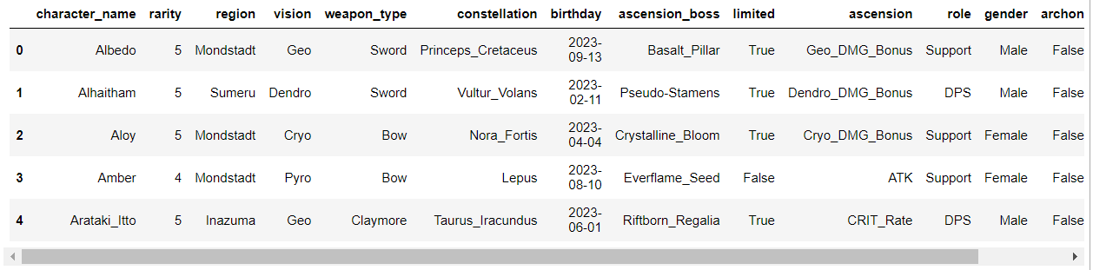

* **Weapons:**
* Name (Name of the weapon)
* Type (One of the 5 types of the weapon)
* Rarity (Can be either 1-Star till 5-Star)
* UpgradeMaterial (Material used to upgrade the weapon)

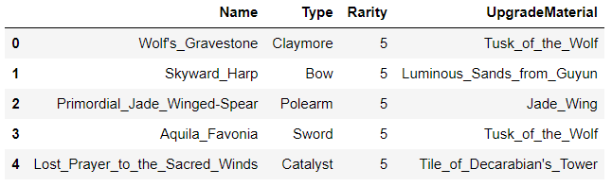

* **Reactions:**
* Element (Element involved in a reaction)
* causesReaction (Reaction caused by that element)

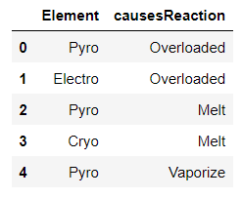

* **Enemies:**
* Name (Name of the enemy)
* Element (Element possessed by the enemy)
* WeakAgainst (Element the enemy is weak against)
* EnemyType (One of the 4 different types an enemy can be)
* DropsMaterial (Material dropped by the enemy)

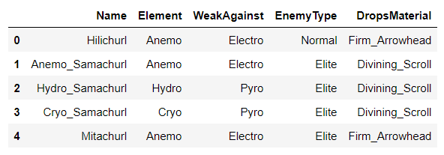

# **Conceptual Model**

There are 2 forms of conceptual models we have made, the first one is the true conceptual model but it will be extremely hard to interpret because it’s too large. Here it is:

It also has the Wikidata relations included.

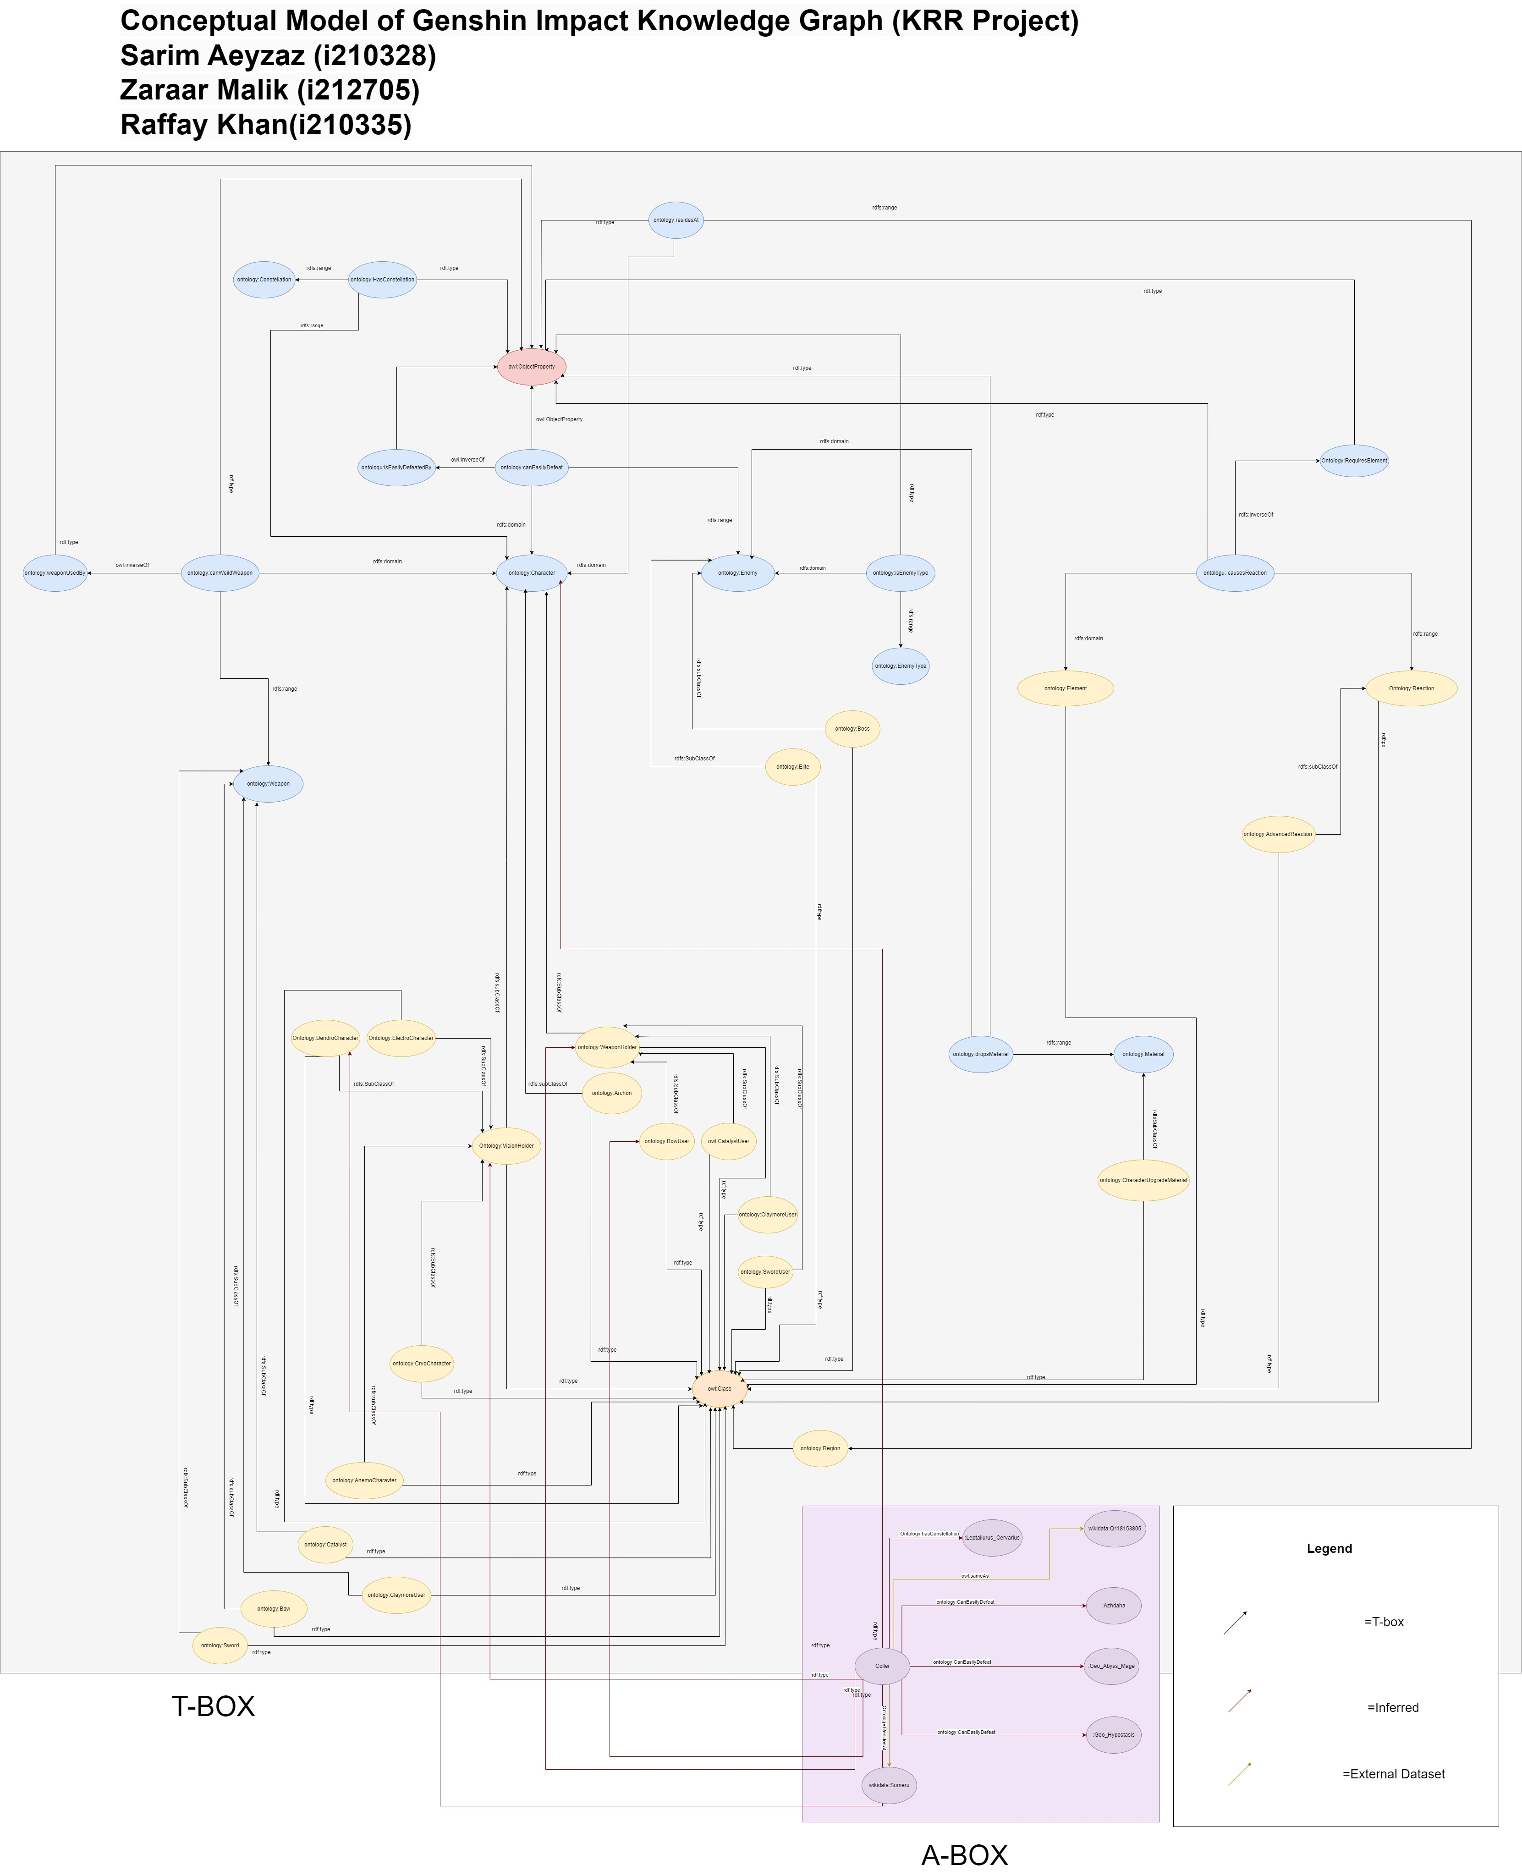

Link to conceptual model: <https://drive.google.com/file/d/1STxGt5KberewhSH27bZgwpgtAY0CPybP/view?usp=sharing>

Here is the second one which is taken from Protégé (it’s missing the object properties but at-least it is readable:

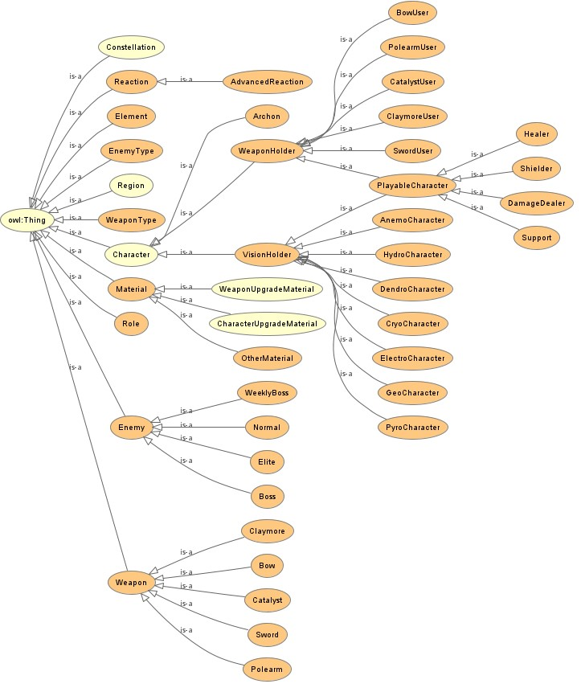

## Identified Vocabularies

* canEasilyDefeat
* canWeildWeapon
* causesReaction
* dropsMaterial
* elementAlignment
* enemyWeakAgainst
* hasConstellation
* hasResident
* hasRole
* isEasilyDefeatedBy
* isEnemyType
* isWeaponType
* requiresElement
* residesAt
* usesCharacterUpgradeMaterials
* usesWeaponType
* usesWeaponUpgradeMaterial
* weaponUsedBy
* birthday
* hasAscensionPassive
* hasGender
* isArchon
* isLimitedCharacter
* rarity
* releaseDate
* foaf:name

# **External Linked Dataset**

I tried to search a lot for an external dataset related to Genshin but sadly, I couldn’t find a single thing. The only source I could find is partial information on character only in Wikidata and thus, just decided to link all character of Genshin listed on Wikidata to my characters.

However, do note that Wikidata doesn’t have every character of Genshin impact on its website so not every single character could be linked :(.

Here it is: <https://www.wikidata.org/wiki/Q65059474>

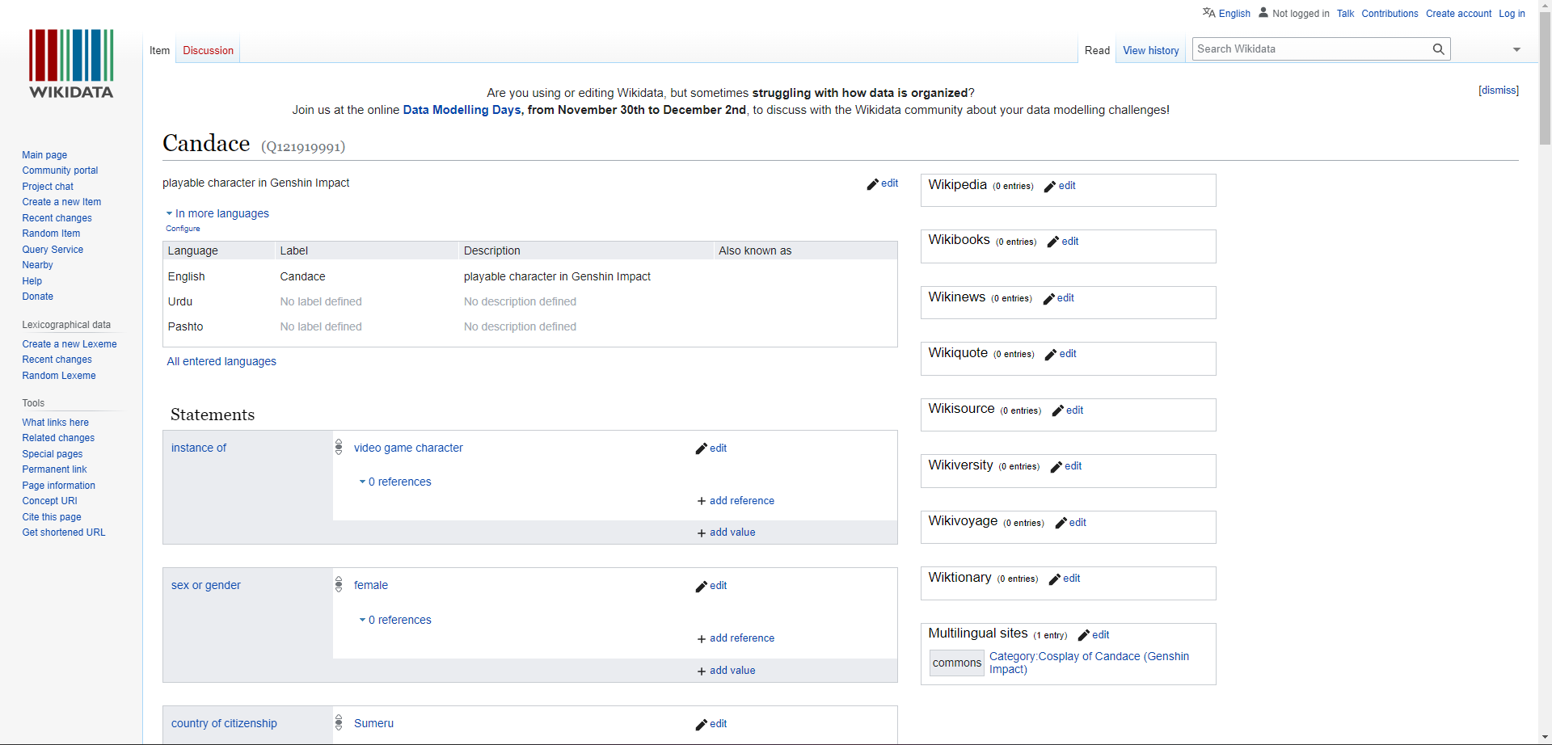

# **Designing the Ontology**

## Ontology Class Hierarchy

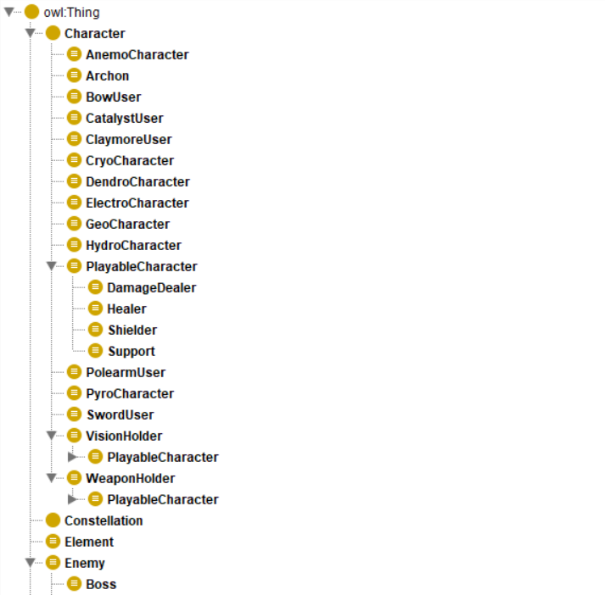 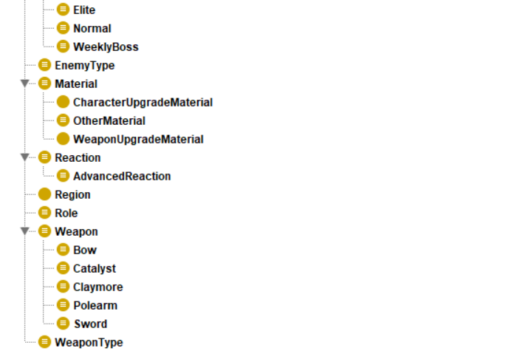

**Description:**

In this class diagram, most of these classes are supposed to be inferred. This was done to increase the semantic expressivity of the data (And allow SWRL rules usage later on).

Below were the requirements for the Ontology file, I’ll list each one of them and highlight where they are fulfilled with a justified reason:

## Ontology 11 Requirements

1. **At least one class defined as enumeration of its individuals:**

In my ontology, four classes were defined as enumerations, Element, Role, EnemyType and WeaponType.

* Elements contain 7 individuals (Pyro, Cryo, Anemo, Geo, Dendro, Electro, Hydro)
* Role contains 4 individuals (DPS, Healer, Shielder, Support).
* EnemyType contains 4 individuals (Normal, Elite, Boss, Weekly Boss)
* WeaponType contains 5 individuals (Spear, Bow, Claymore, Polearm, Catalyst)

It’s heavily implied that there will be 7 elements only throughout the entire story and there are 4 major roles in the game currently. This sits well with the game’s design since you can have a maximum of 4 characters in your party. EnemyType and WeaponType may increase in the future but it’s been 3 years since the game’s launch and these have stayed the same.

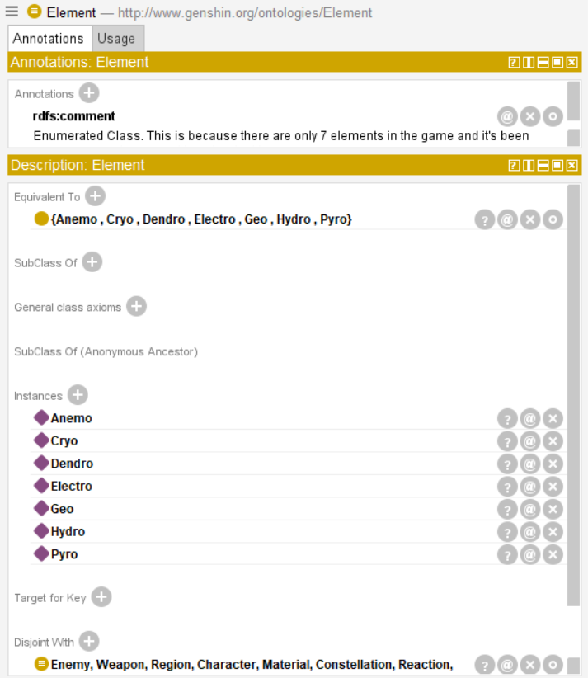 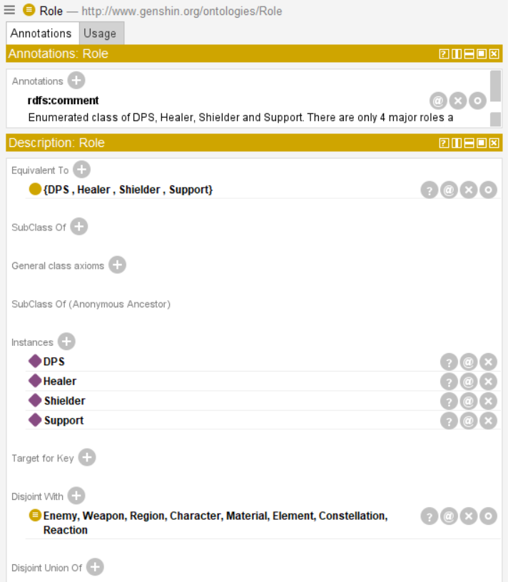

1. **At least one class defined using property cardinality restrictions:**

All reactions in Genshin happen between at-least 2 elements (and advanced reactions occurring between more than 2 elements. Therefore, cardinality restrictions are placed where each individual needs to be related to ‘requiresElement’ to 2 or more than 2 Elements respectively.

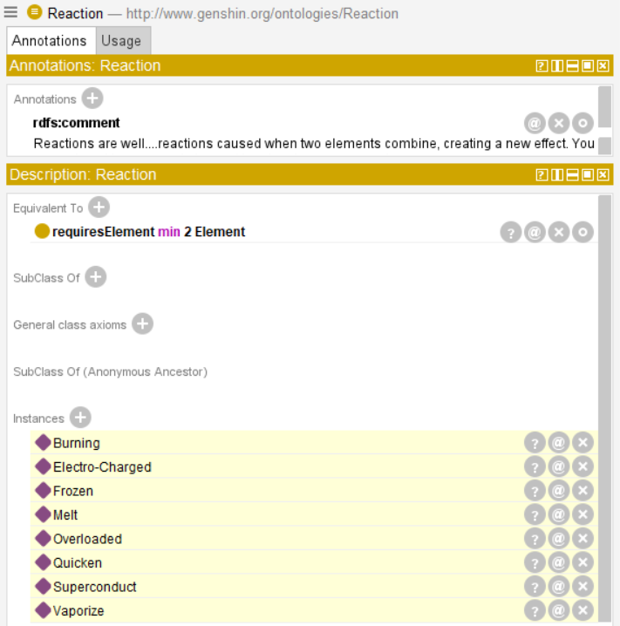 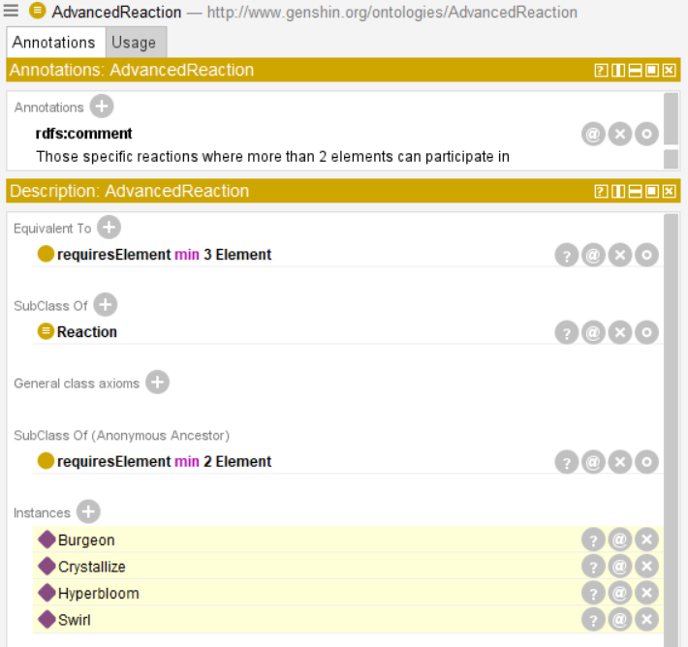

1. **At least one class defined using property range restriction**

Almost all of my character classes are defined using this method. GeoCharacter, AnemoCharacter, HydroCharacter, CryoCharacter, PyroCharacter, DendroCharacter, GeoCharacter needs to have an individual which is related to “elementAlignment” property on a specific element (e.g. CryoCharacter individual needs to have elementAlignment to cryo), BowUser, ClaymoreUser, PolearmUser, CatalystUser and SwordUser are related in a similar manner.

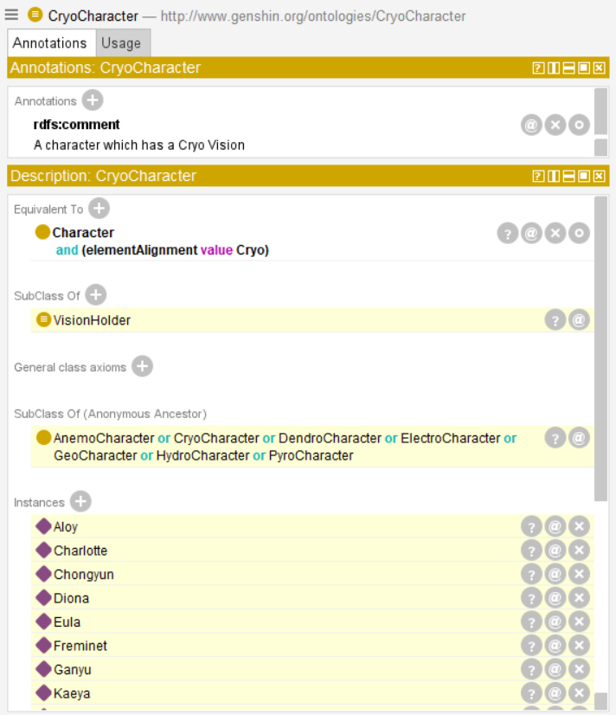 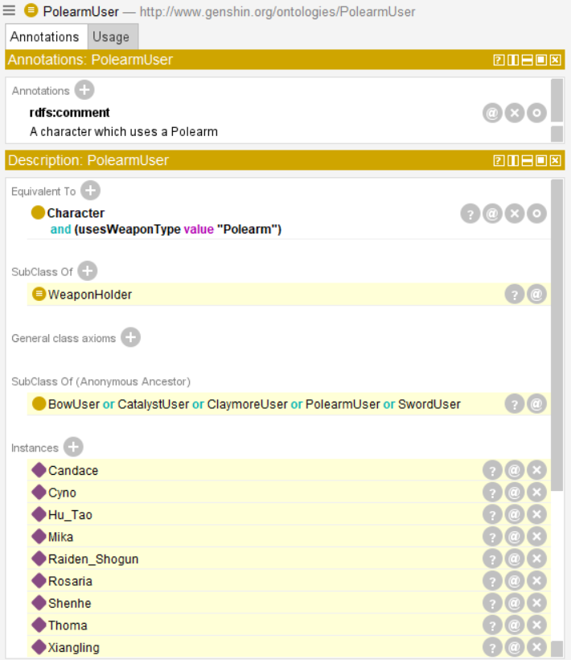

1. **At least one class defined as a union of classes**

Vision holder class is a union of property restricted class of characters of each element. Similarly, Weapon holder is a union of property restricted class of character of each weapon type:

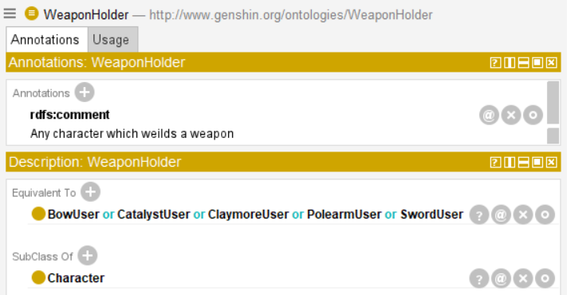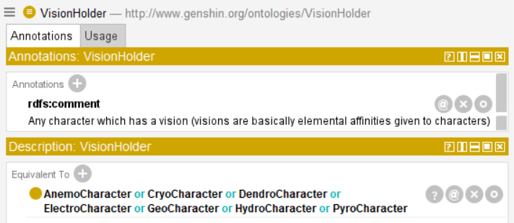

Materials class is also a union of CharacterUpgradeMaterials and WeaponUpgradeMaterials. Similarly, Weapon class is a union of all people weapon type classes:

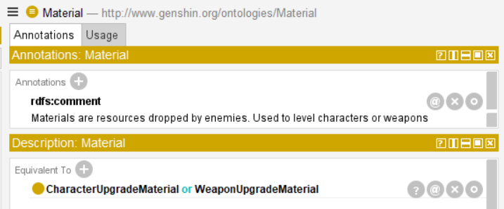 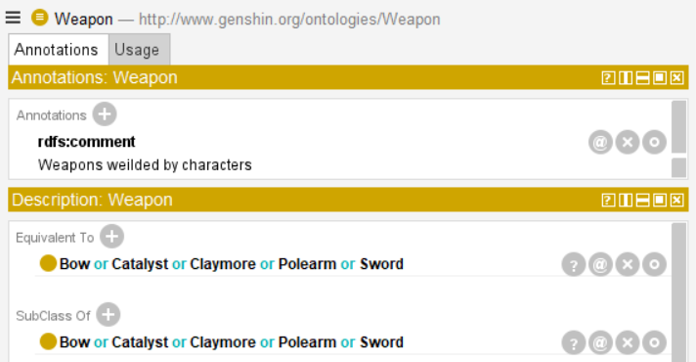

1. **At least one class defined as an intersection of classes**

PlayableCharacters is one such class where if a character is both a vision holder and wields a weapon, they are deemed as playable characters. (Since all playable characters in Genshin hold a vision and are able to wield a weapon)

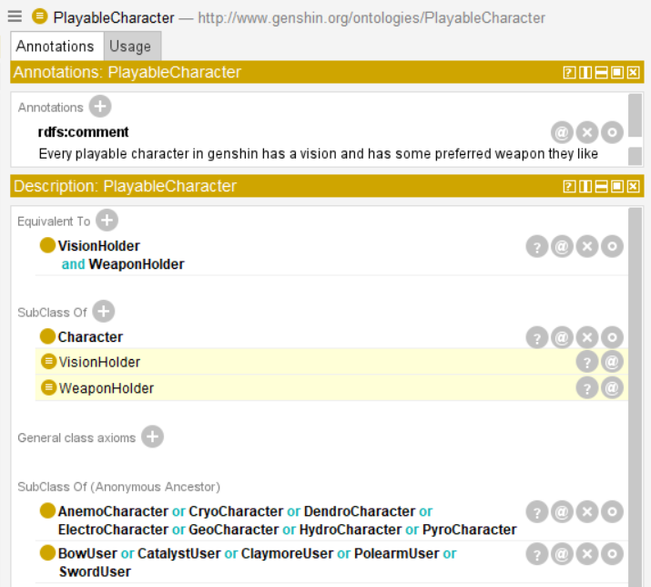

1. **At least one class defined as a complement of classes**

Here, we have other materials defined as those materials which are not character upgrade materials nor weapon upgrade materials:

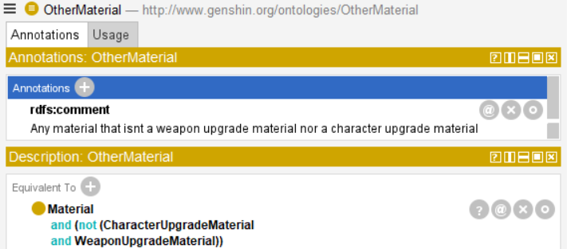

1. **At least 7 object properties in total**

Here you go :D. There’s annotations for each object property explaining it too in the RDF/XML file.

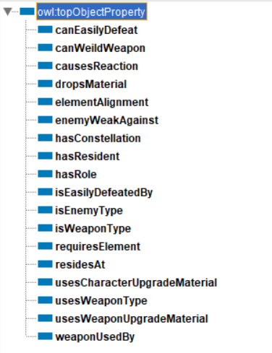

1. **At least one object property should be functional**

ElementAlignment is a functional property. It's made functional because a character cannot have more than 1 element. If they do, it should mean that the two element instances are the same individuals. This is a fact imposed by the story of Genshin for all of its characters. Even the archons have only 1 element aligned to them.

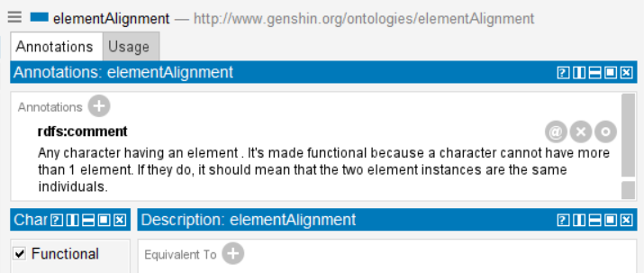

1. **At least one object property should be inverse functional**

hasConstellation is an inverse functional property. Every character has their own unique constellation in the game (To be more in-depth without spoiling, it represents ‘them’ in the ‘sky’). Therefore, a constellation cannot belong to more than 1 character. If that case ever happens, then both character individuals are to be inferred as the same individual.

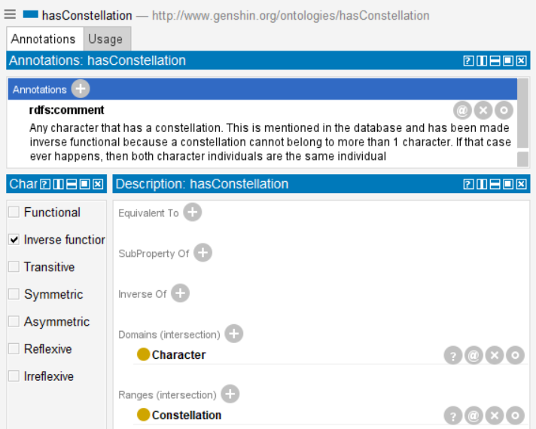

1. **At least 3 object properties should have some range restrictions**

Here you go! I’ll show 4 of them but a lot of my object properties have range and domains restrictions:

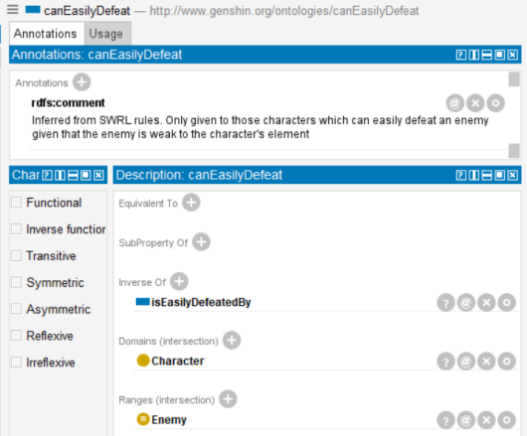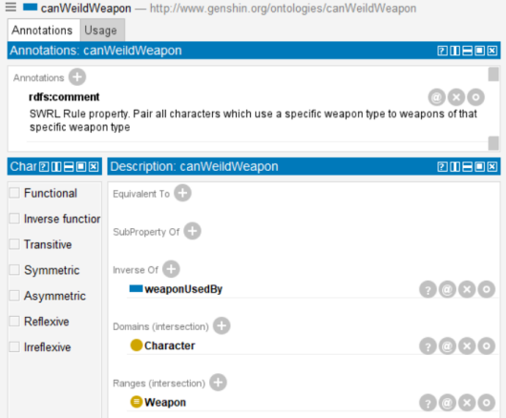

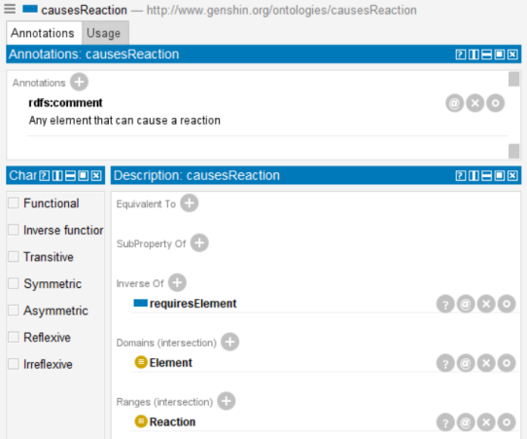 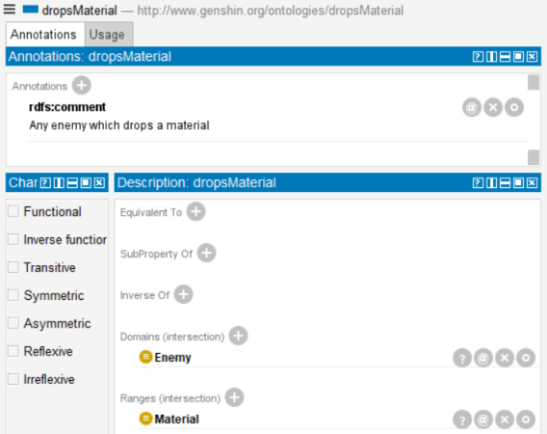

1. **At least 7 datatype properties in total**

Here you go!

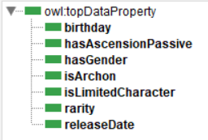

# **Mapping**

Here are the 4 databases I used to map into my RDF/XML ontology:

## Character Table (Displaying only 5 rows)

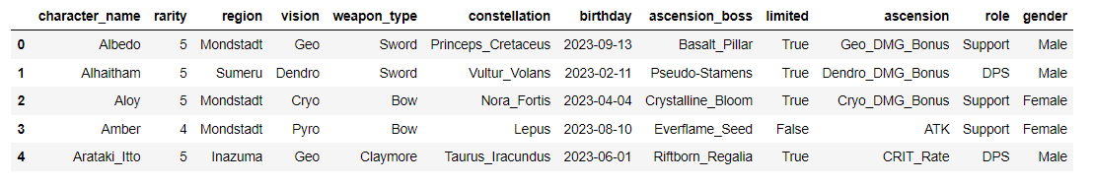

## Reaction Table (Displaying only 5 rows)

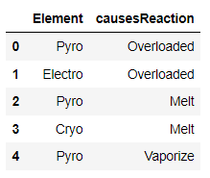

## Weapons Table (Displaying only 5 rows)

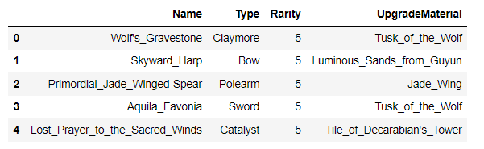

## Enemies Table (Displaying only 5 rows)

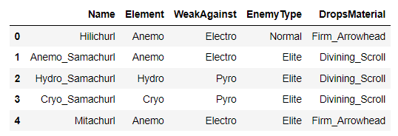

First I parsed my ontology using RDFLib library, and then, it was just a matter of adding the right triples into the graph. Here’s an example of what it looks like for Characters:

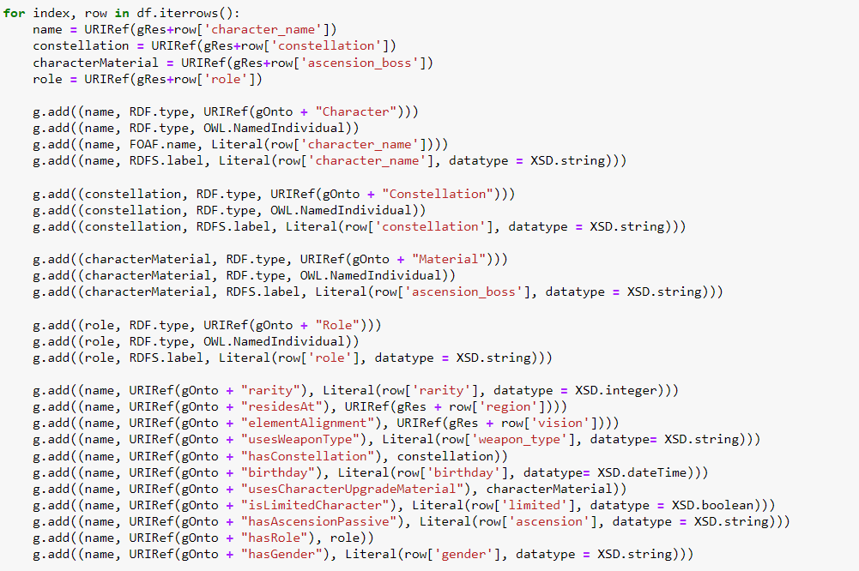

After every time I added a table, I saved the updated ontology into a new file:



# **Linking**

Genshin Impact characters from Wikidata were linked with my characters in my ontology. Unfortunately, Wikidata didn’t contain all of the characters so only some characters could be linked to there.

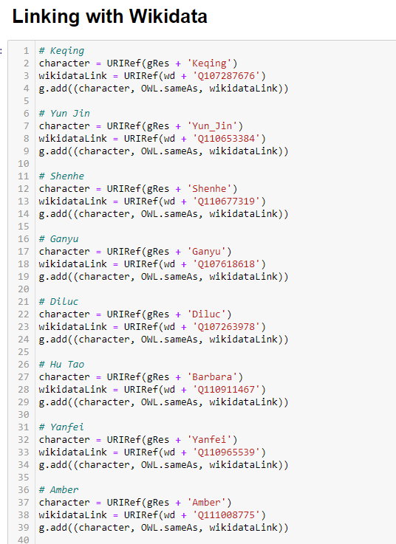

As such, 30 characters were successfully linked with Wikidata

# **Reasoning**

## SWRL Rules

**Rule 1-5:**

I wanted to make some inferences that if there is a character belonging to BowUser defined class, then it should be able to wield every single instance of Bow class. Unfortunately, OWL didn’t have the expressivity to allow this so I had to use some SWRL rules to make these inferences possible. Here’s how the above situation looks like as a SWRL rule:

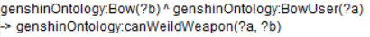

As such, 5 rules were made like this, each one trying to make inferences between specific weapon types and their respective holders.

**Rule 6:**

Another place SWRL rule was implemented was to answer one of my competency question: “What characters can easily defeat X enemy?”

I had the weakness element of the enemy and each character’s element alignment. All I had to do in SWRL was to make such question’s relation a possibility. Here’s how it looks like:



It’s a bit long, I know. Class type checks had to be in place so I wouldn’t get any information where “Enemy” is weak against “Enemy”. Since enemy shouldn’t be the domain of this property.

## Reasoning

After running the reasoner, we notice a lot of stuff happening. Here are all the places where the reasoner inferred something (SWRL rule reasonings are at the bottom):

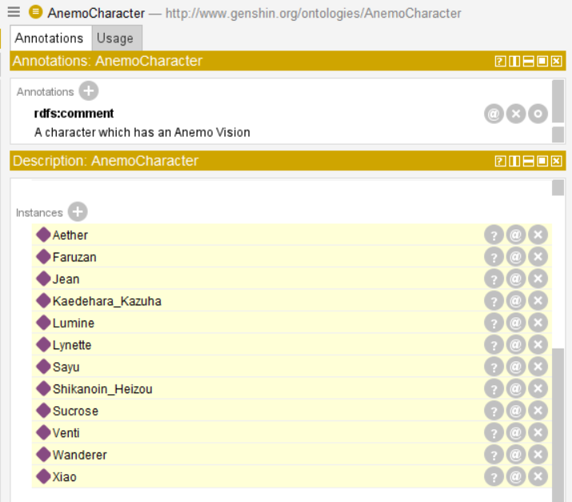

For element specific character classes, it perfectly reasoned which characters should belong into which elemental class

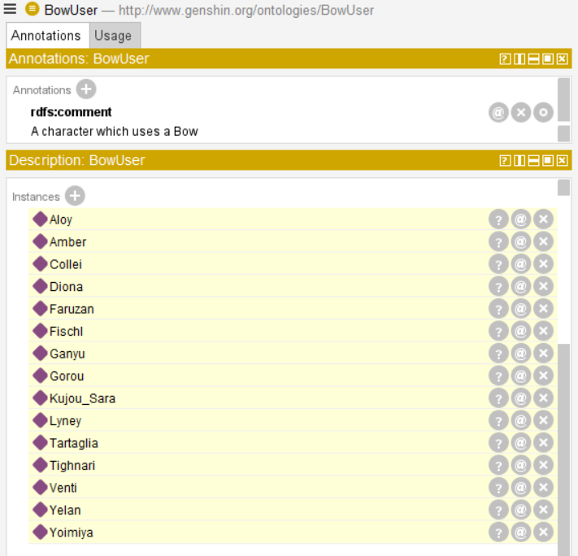

For weapon specific character classes, it perfectly reasoned on which characters wield a bow and thus, are now individuals of BowUser

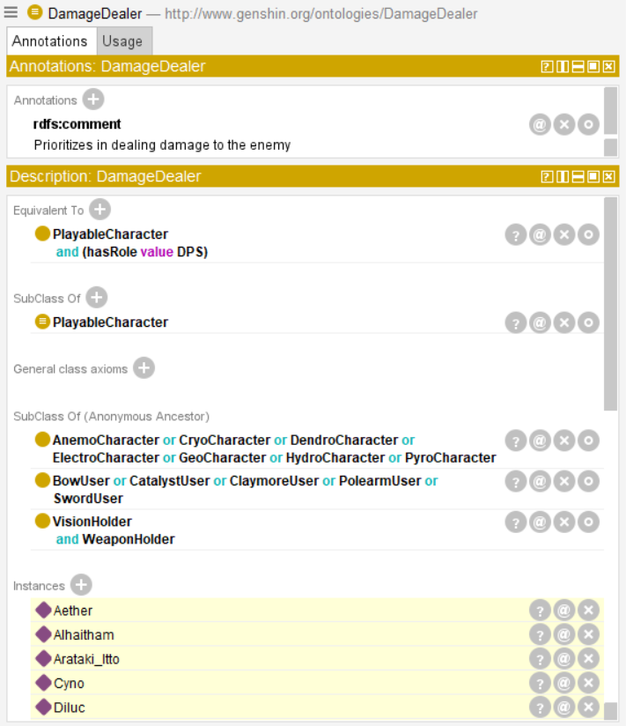

According to the dataset, it also reasoned perfectly on which characters are classified as damage dealers

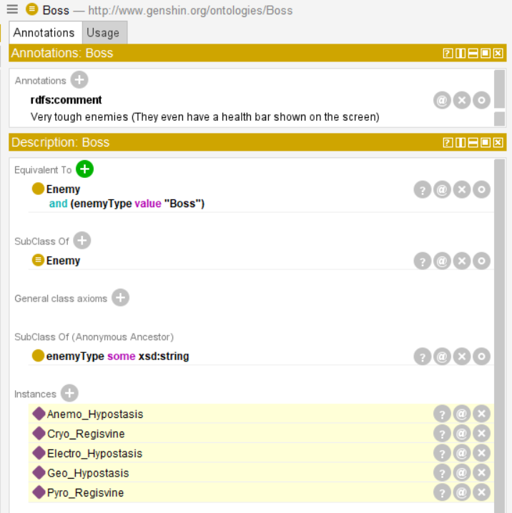

It also reasoned perfectly on which enemies should be considered as individuals of boss class

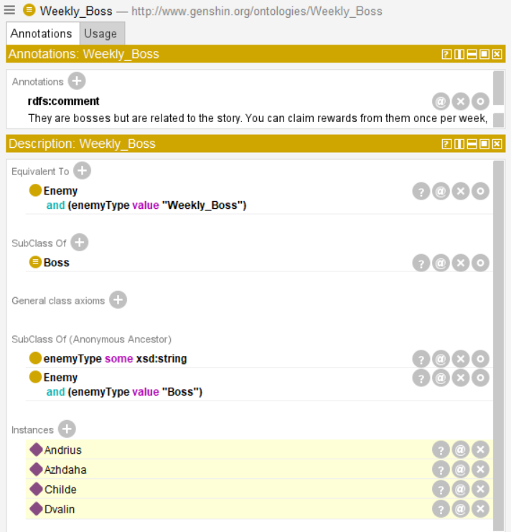

Similarly, it reasoned perfectly on which enemies are of weekly boss types too :D

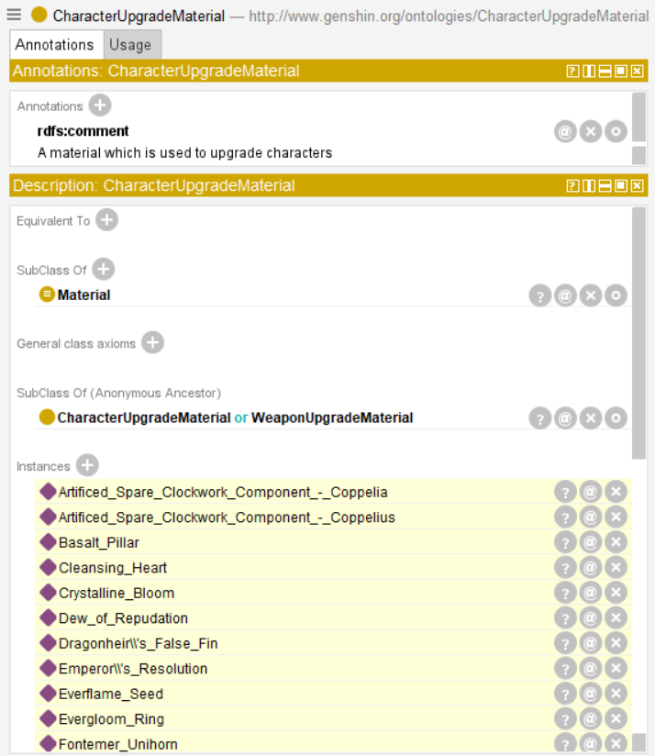

From the materials and characters using those materials, it inferred which materials belong under the CharacterUpgradeMaterials class

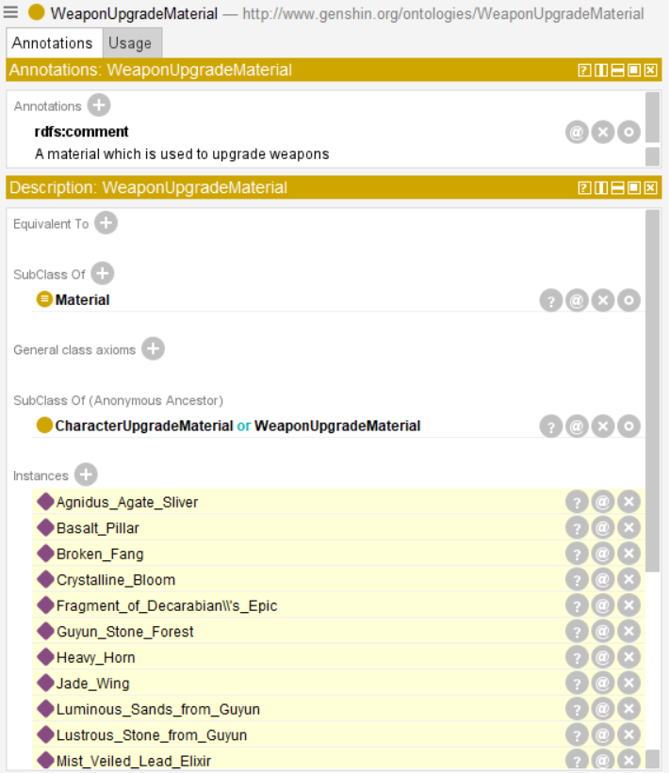

From the materials and weapons using those materials, it inferred which materials belong under the WeaponUpgradeMaterials class

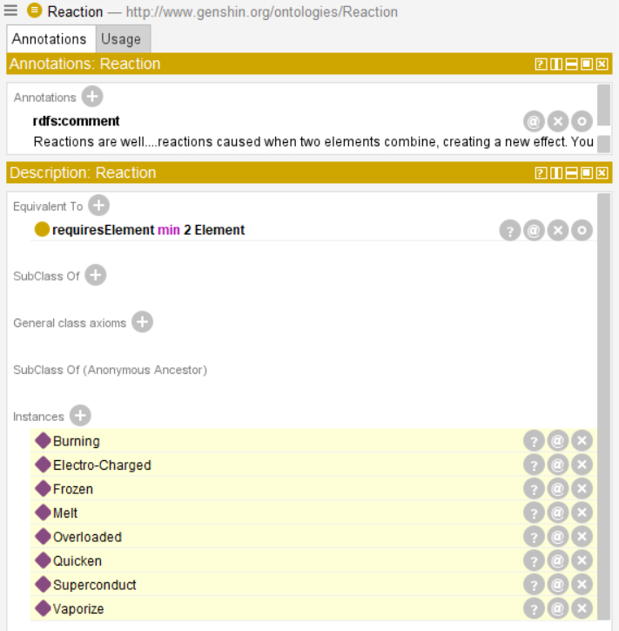

It also inferred correctly on Reactions

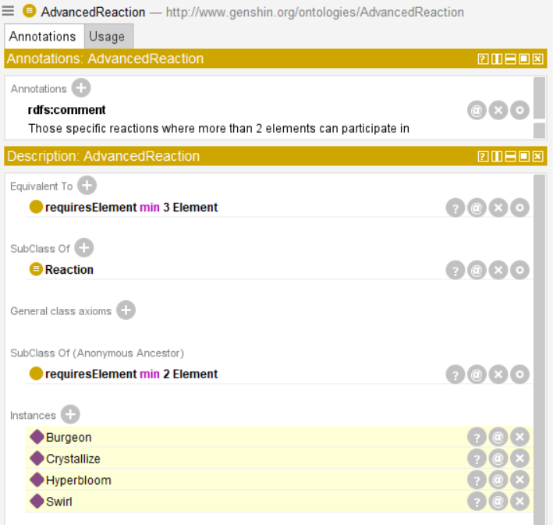

As well as advanced reactions :)

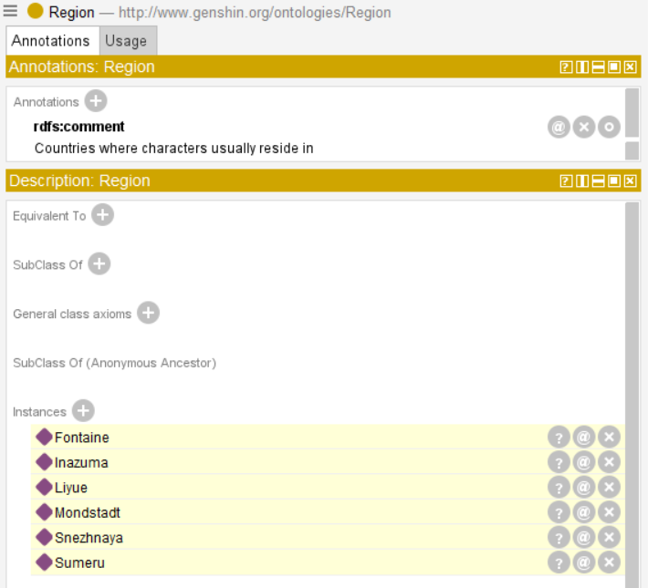

It also inferred the regions automatically

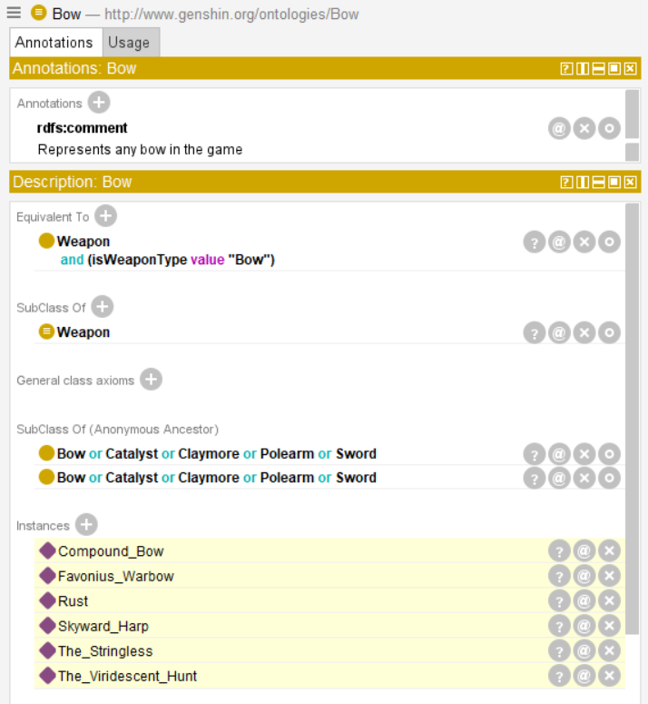 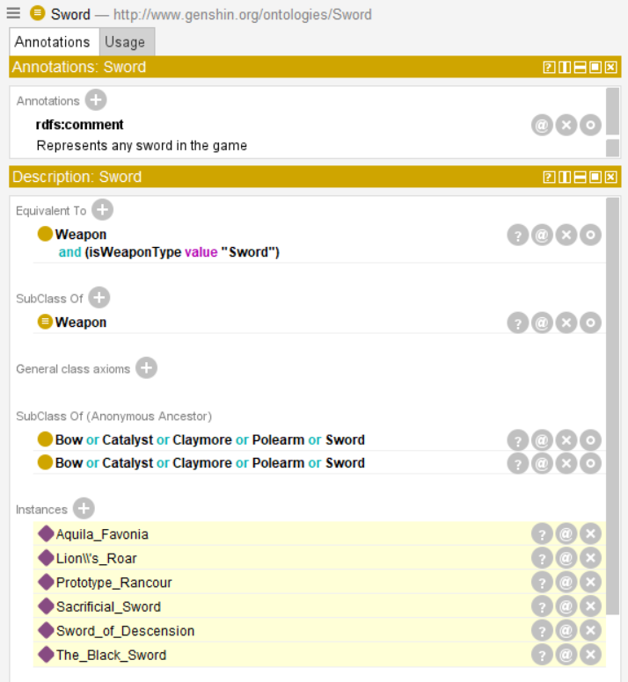

It also correctly inferred on weapons being classified into their respective weapon categories!

## SWRL Reasoning

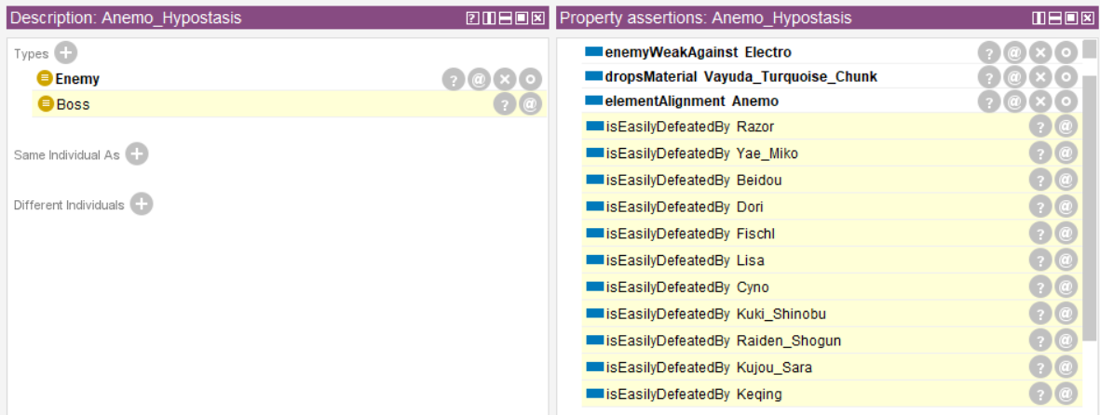

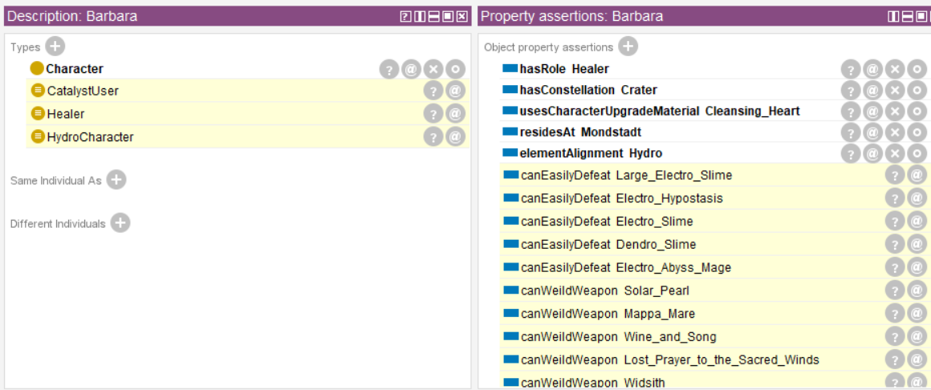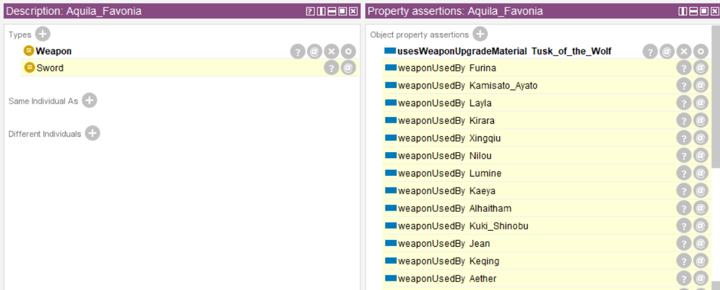

As we can see, SWRL rules allowed such automatic inferences to happen between individuals. This wasn’t possible in OWL because automating relations between instances of 2 different classes (like a dense neural network connection between 2 layers) wasn’t possible with traditional owl expressivity.

**Note:** After mapping and linking, we saved everything into an RDF+XML file called the ‘afterAddingEverything.rdf’. Then we loaded our RDF+XML file into Protege and then we started the reasoner. After triples were reasoned, we saved the file into another RDF+XML file called ‘inferredKnowledgeAdded.rdf’.

## Linked Data Reasoning

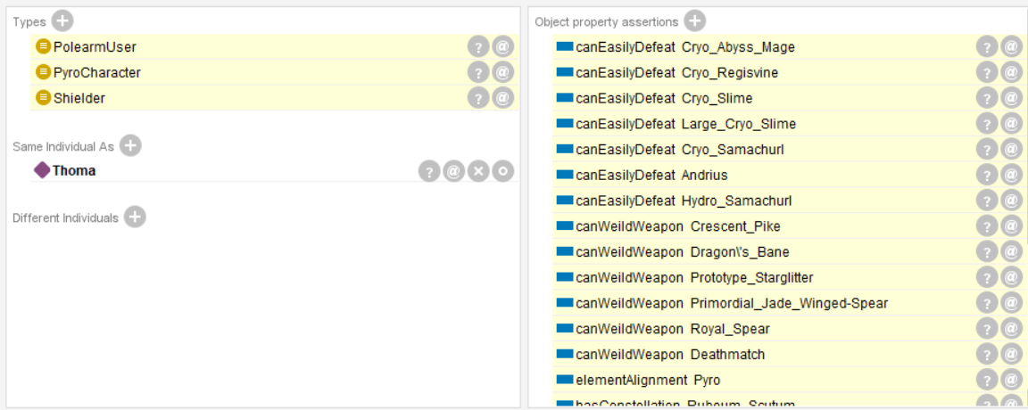

Here you can see the Wikidata entry for Thoma was successfully linked with our Thoma character in the ontology file.

# **Publishing**

## GraphDB

We published the data into GraphDB and Fuseki to create a SPARQL endpoint for our ontology. Here is how it looks like:

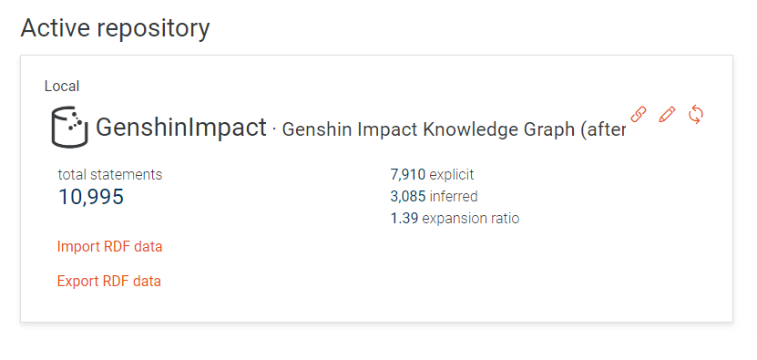

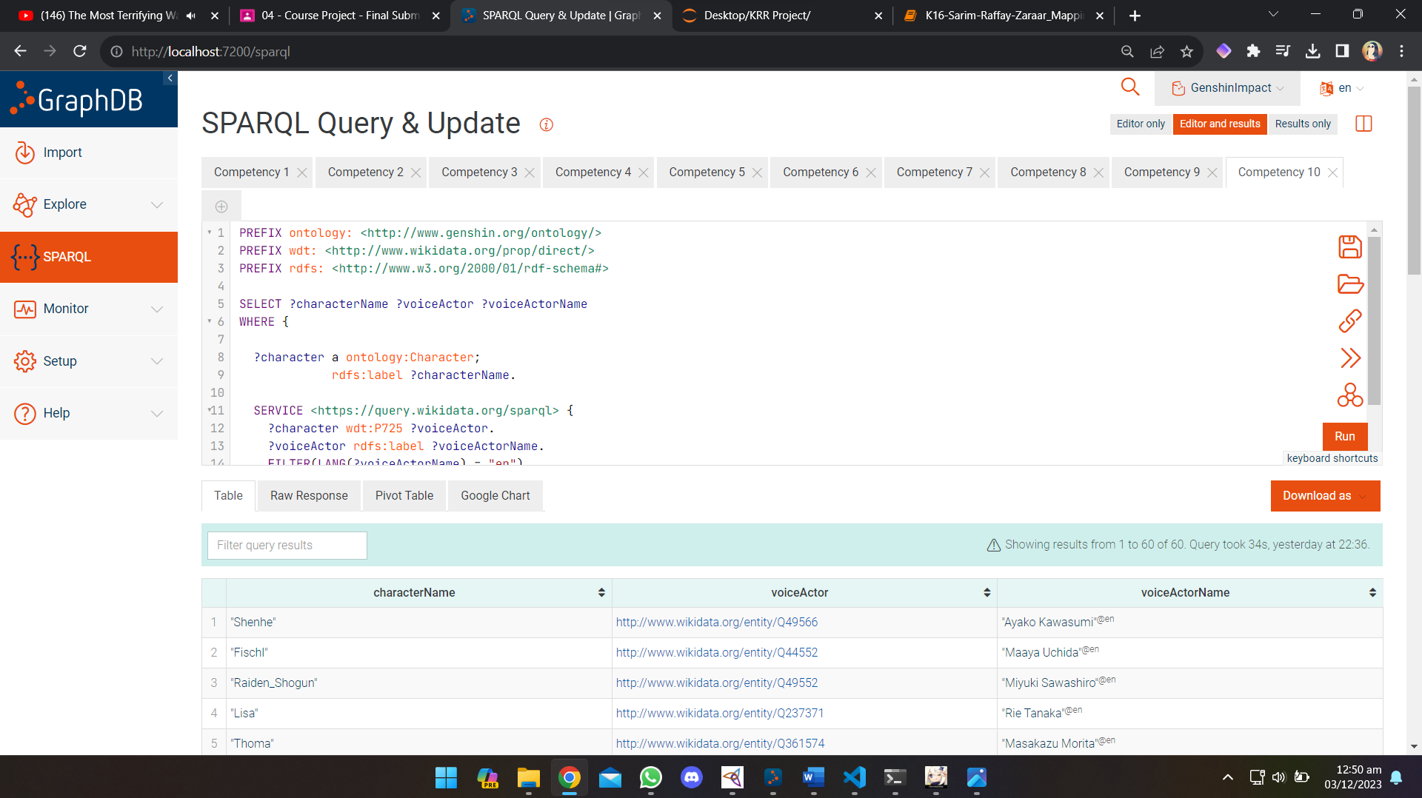

## Fuseki

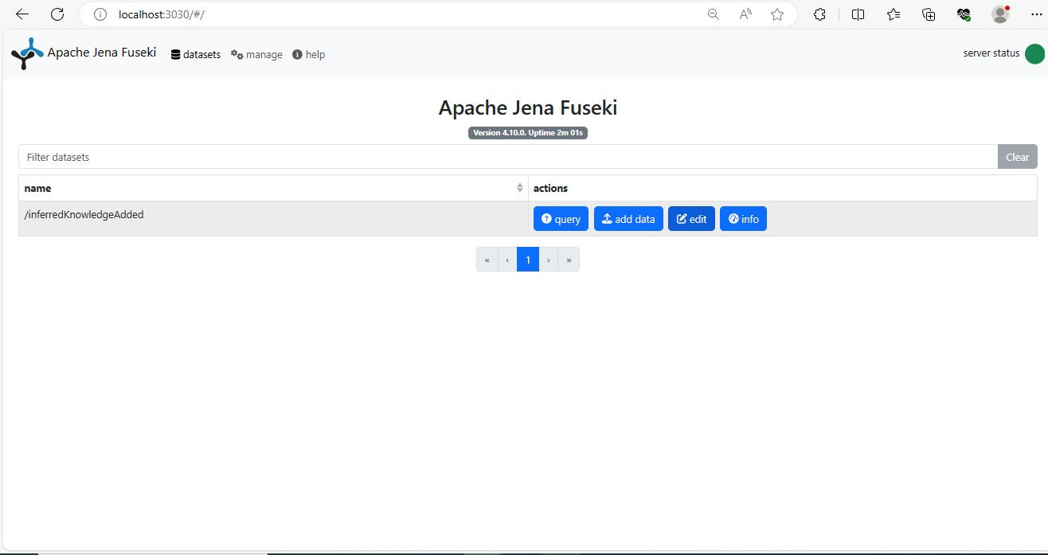

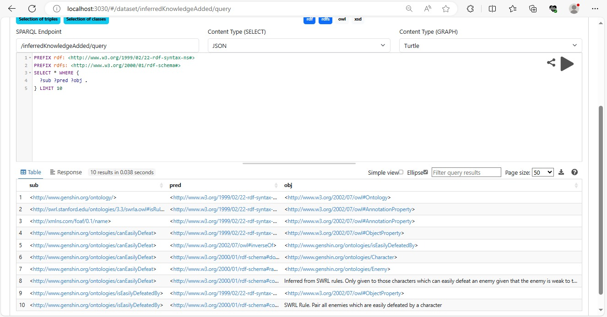

# **Validation Using SPARQL Endpoint**

Here are the 9 ( + 1 bonus ) competency questions we expected our graph to answer. I added the bonus in during deliverable 4 because I was able to do Federated Queries using my graph

**Q1. What materials do I need to level up X character? E.g Kaeya**

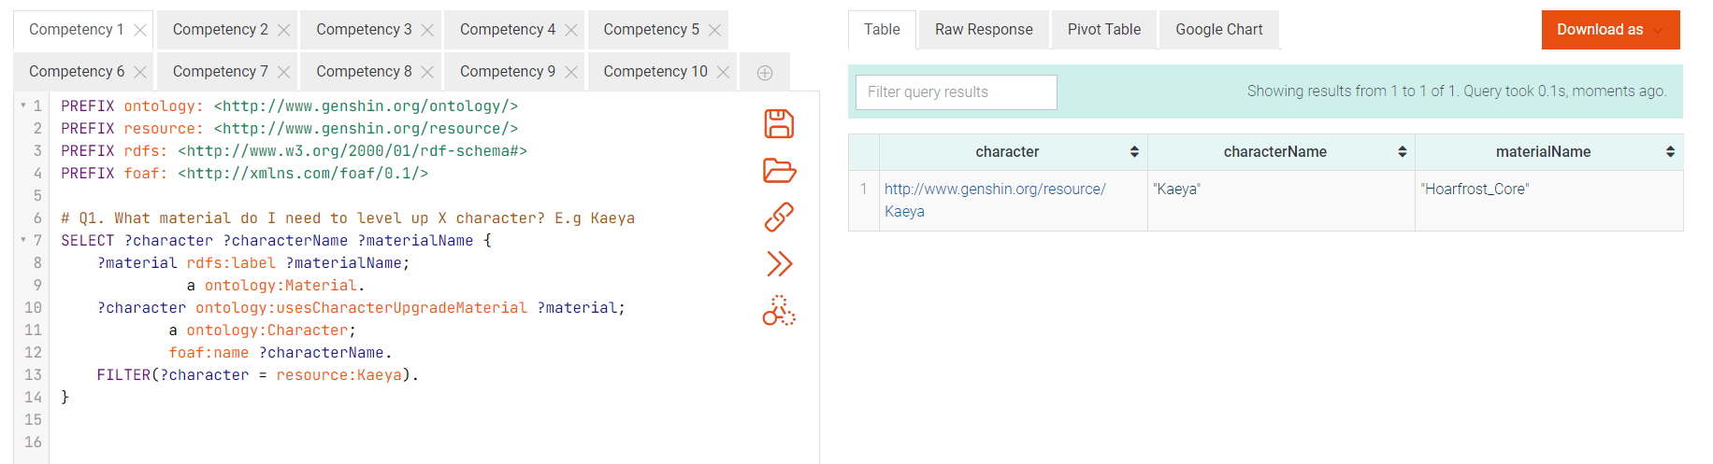

**Q2. What materials do I need to level up X weapon? E.g Favonius Warbow**

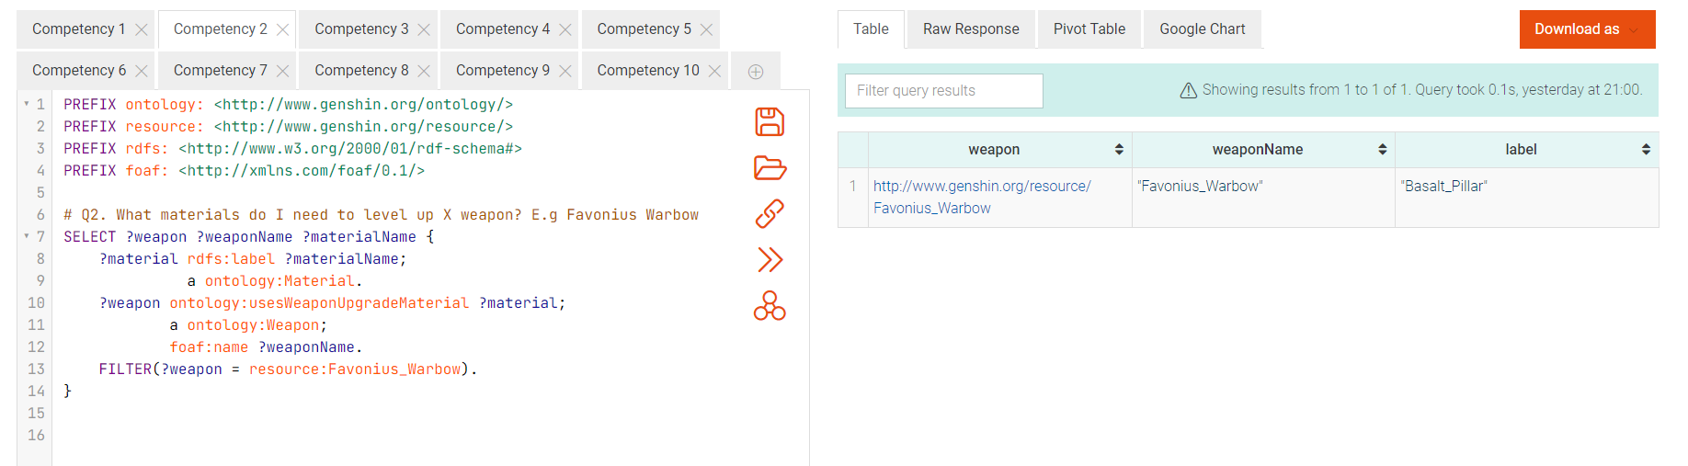

**Q3. List all characters of X element. E.g Hydro**

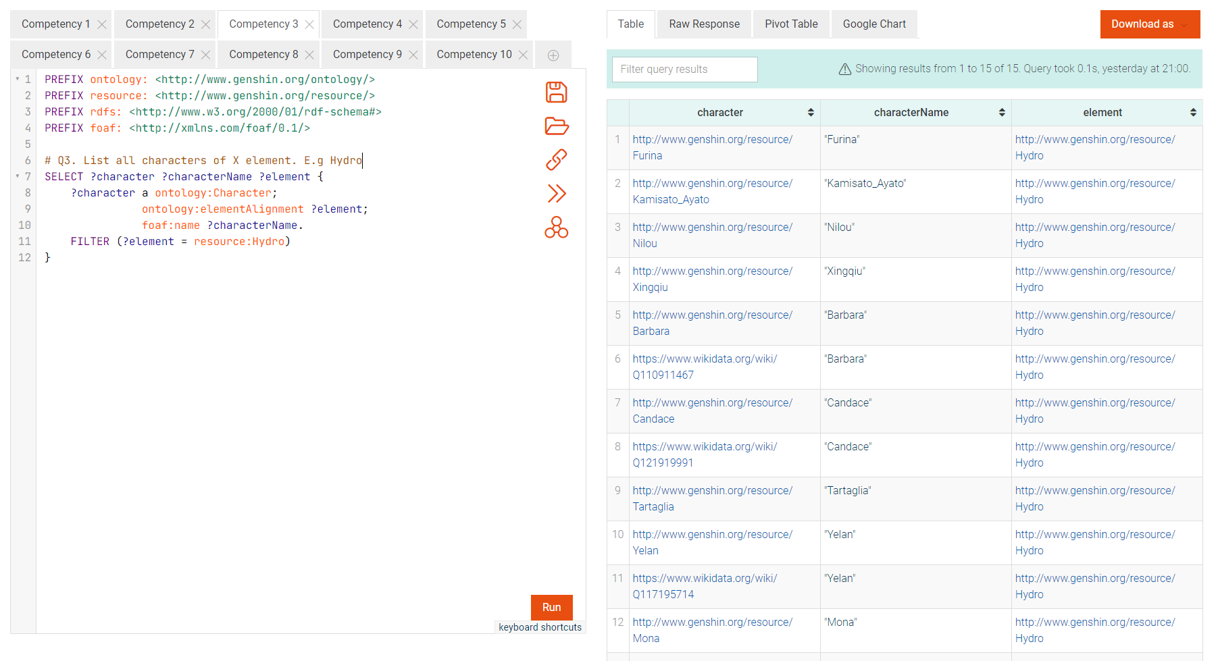

**Q4. Which element is involved in the most reactions?**

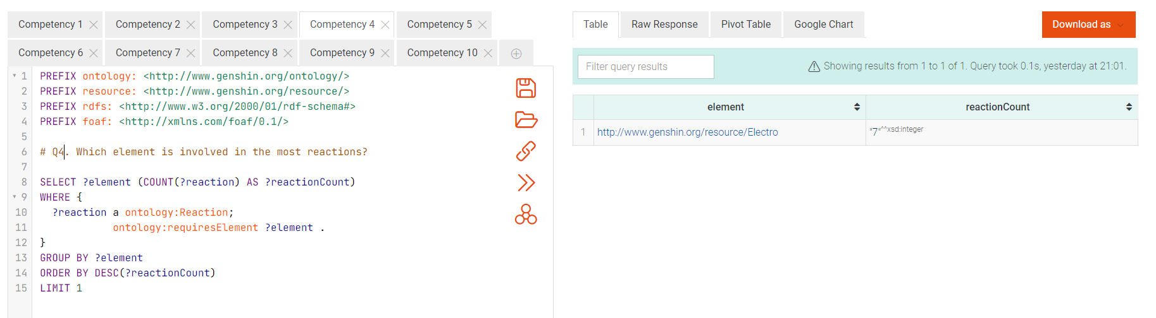

**Q5. Which element has the most healers?**

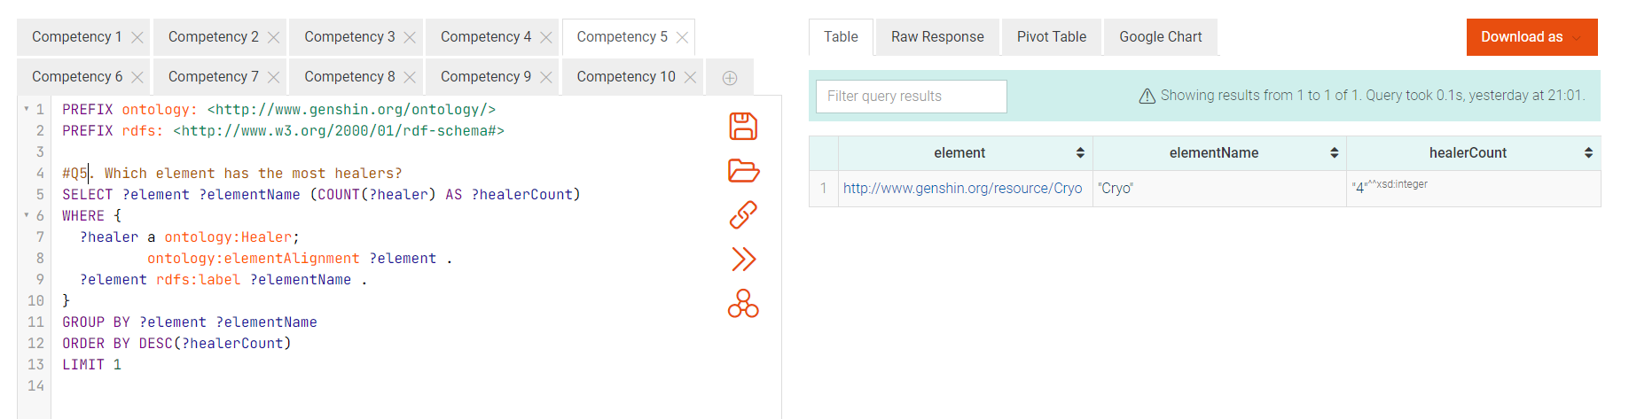

**Q6. List me all the weapons a specific character can use? E.g Kaeya**

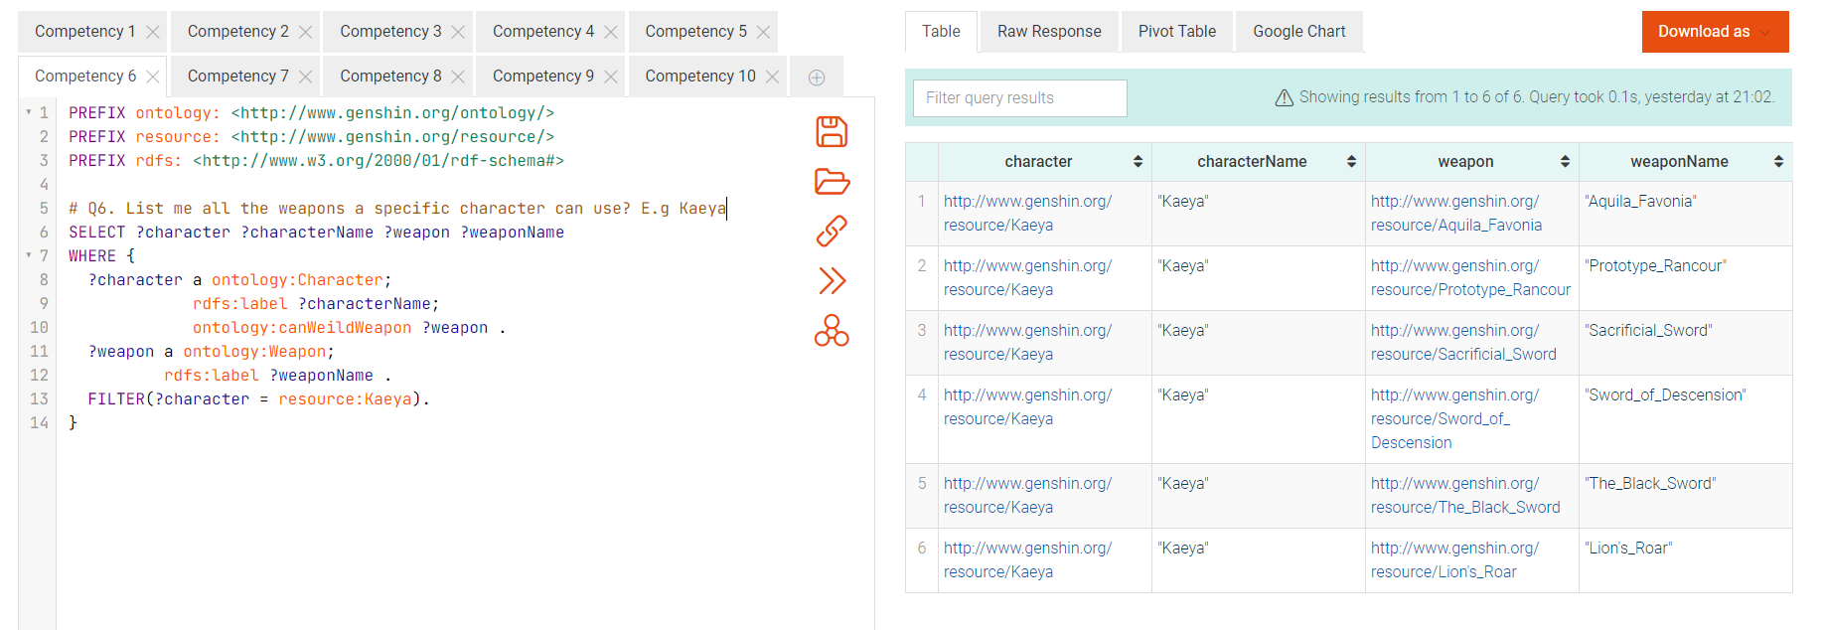

**Q7. What characters are strong against X boss? E.g Pyro Regisvine**

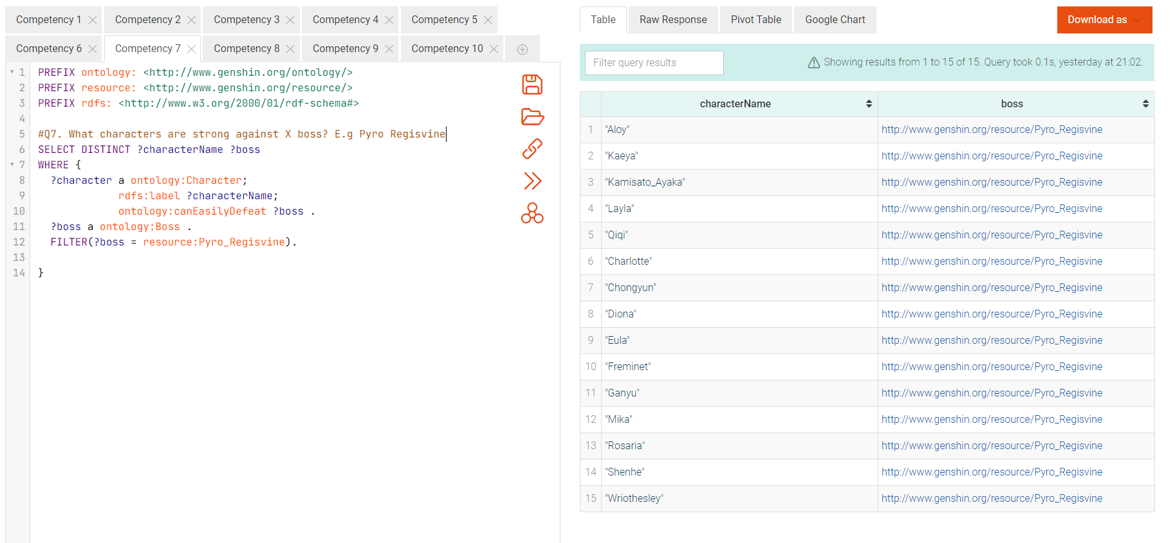

**Q8: What two characters can be used to cause a Vaporize reaction?**

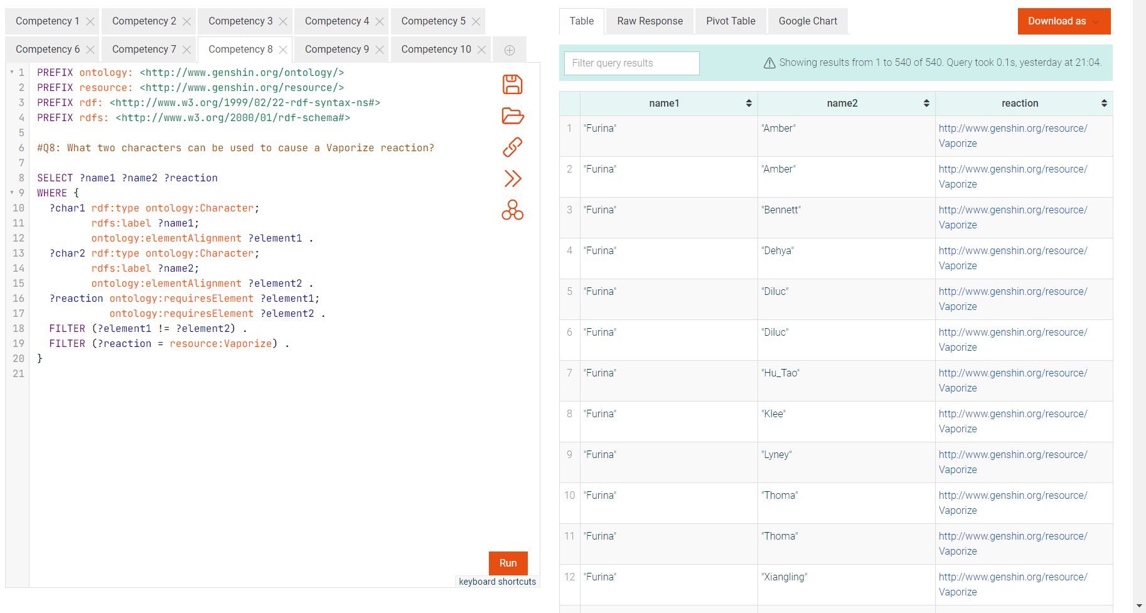

**Q9: List me a team of 4 characters, each with a different role, which can cause a hyperbloom reaction together**

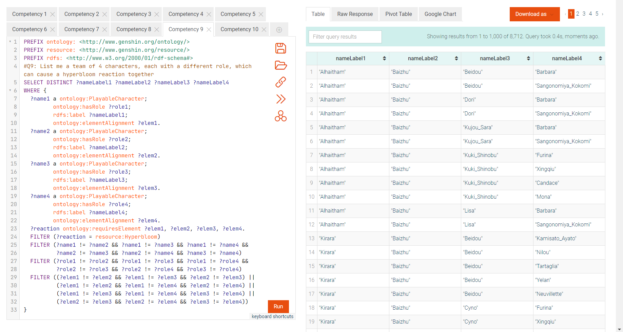

**Q10 (Bonus Federated Query): Get the voice actor names from Wikidata for characters.**

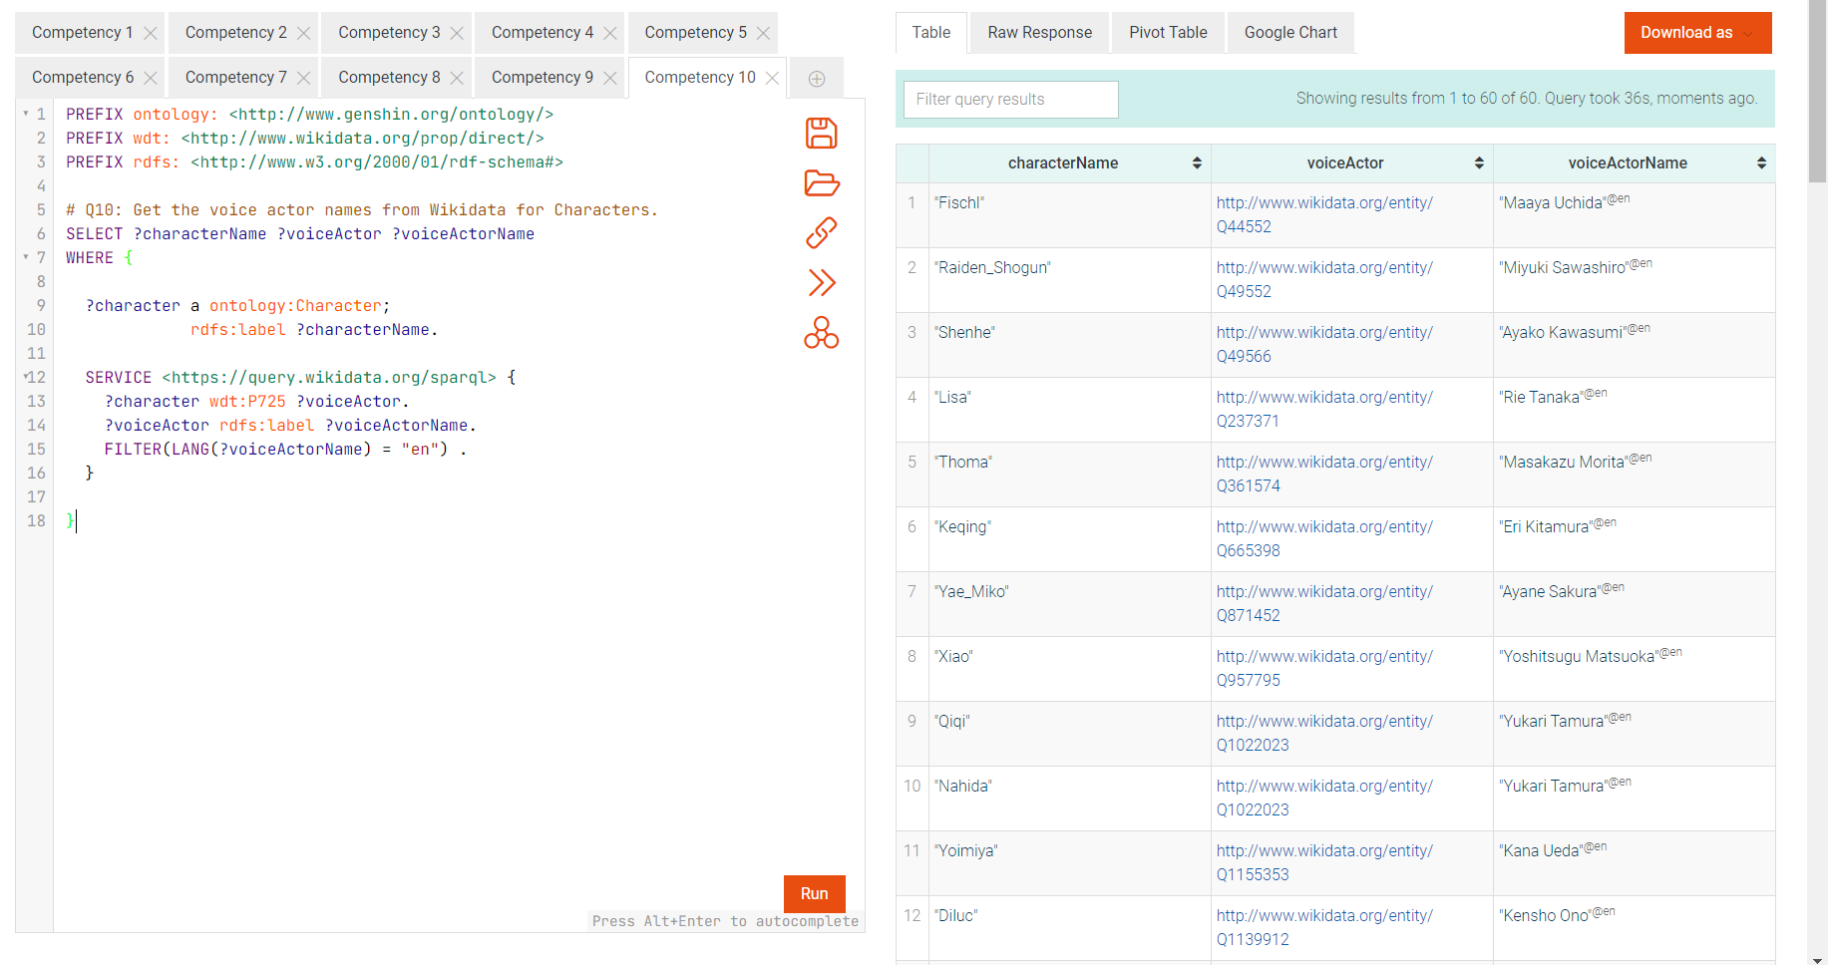

# **Visualizations**

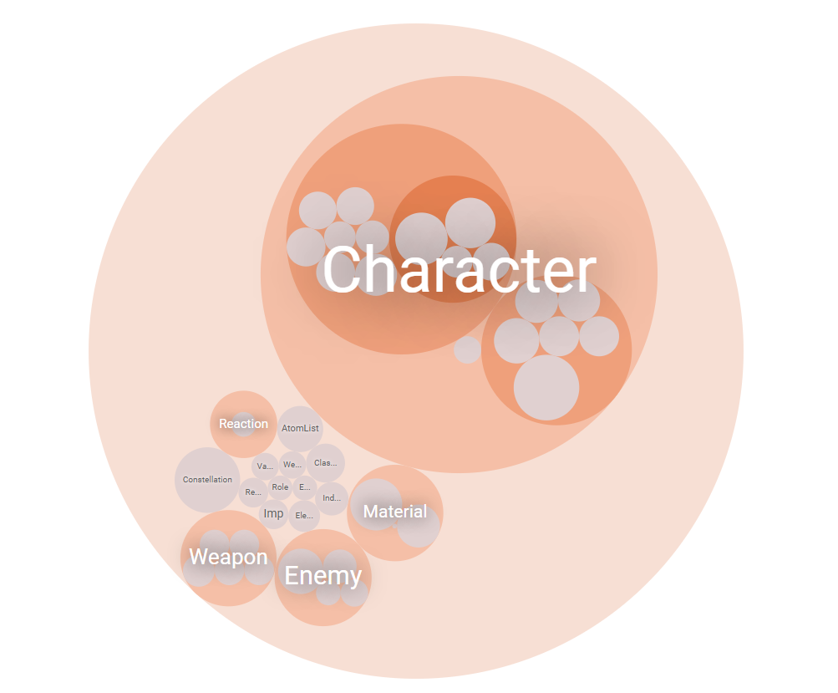

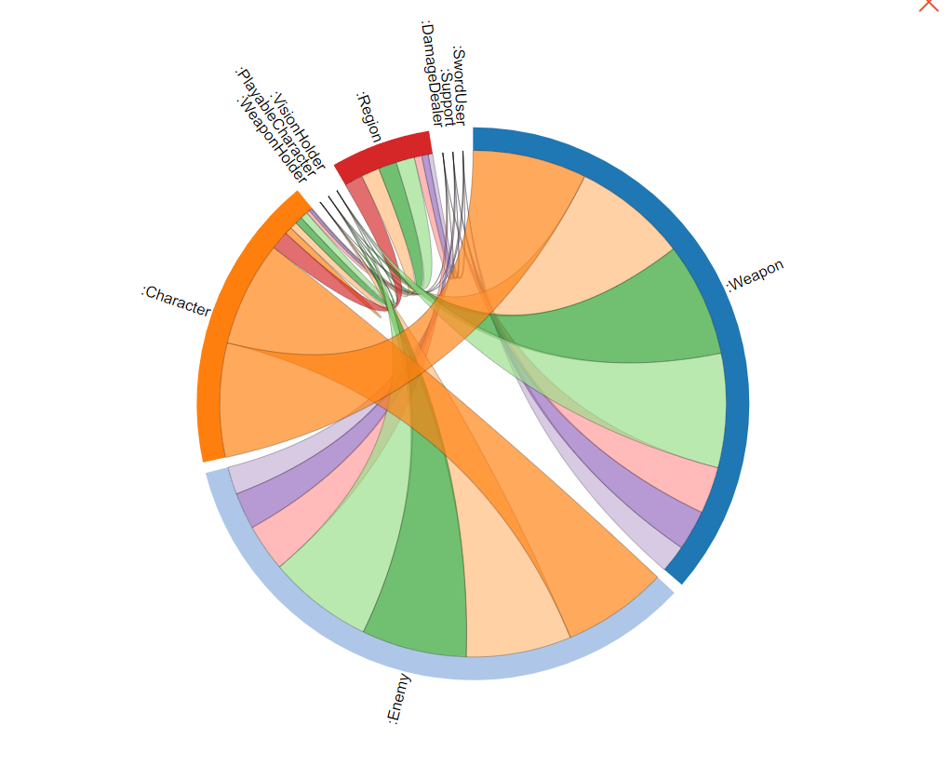

Before adding Inference

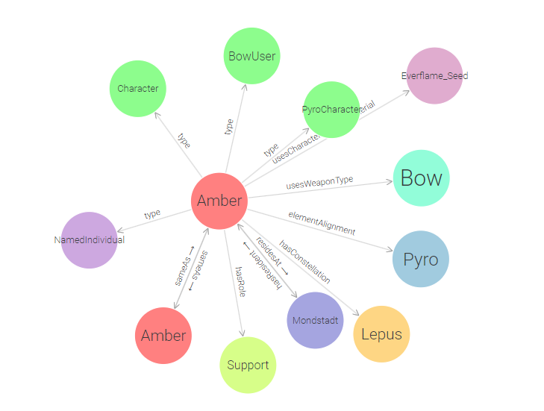

After adding Inference (The second Amber is it’s Wikidata counterpart, I used owl:sameAs for it)

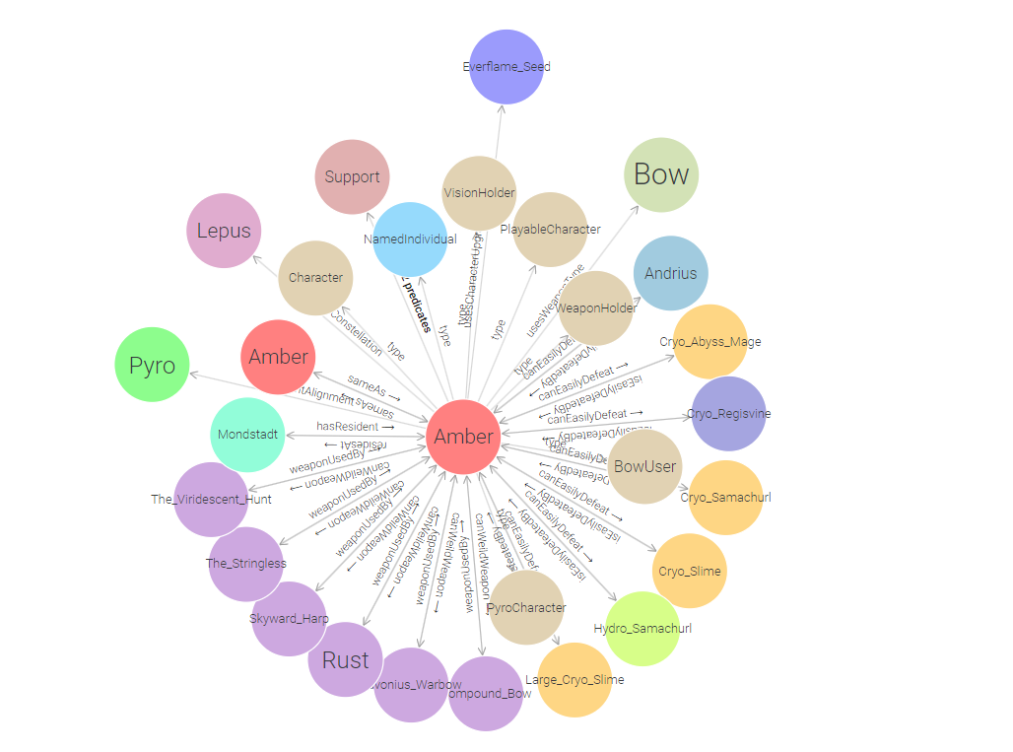

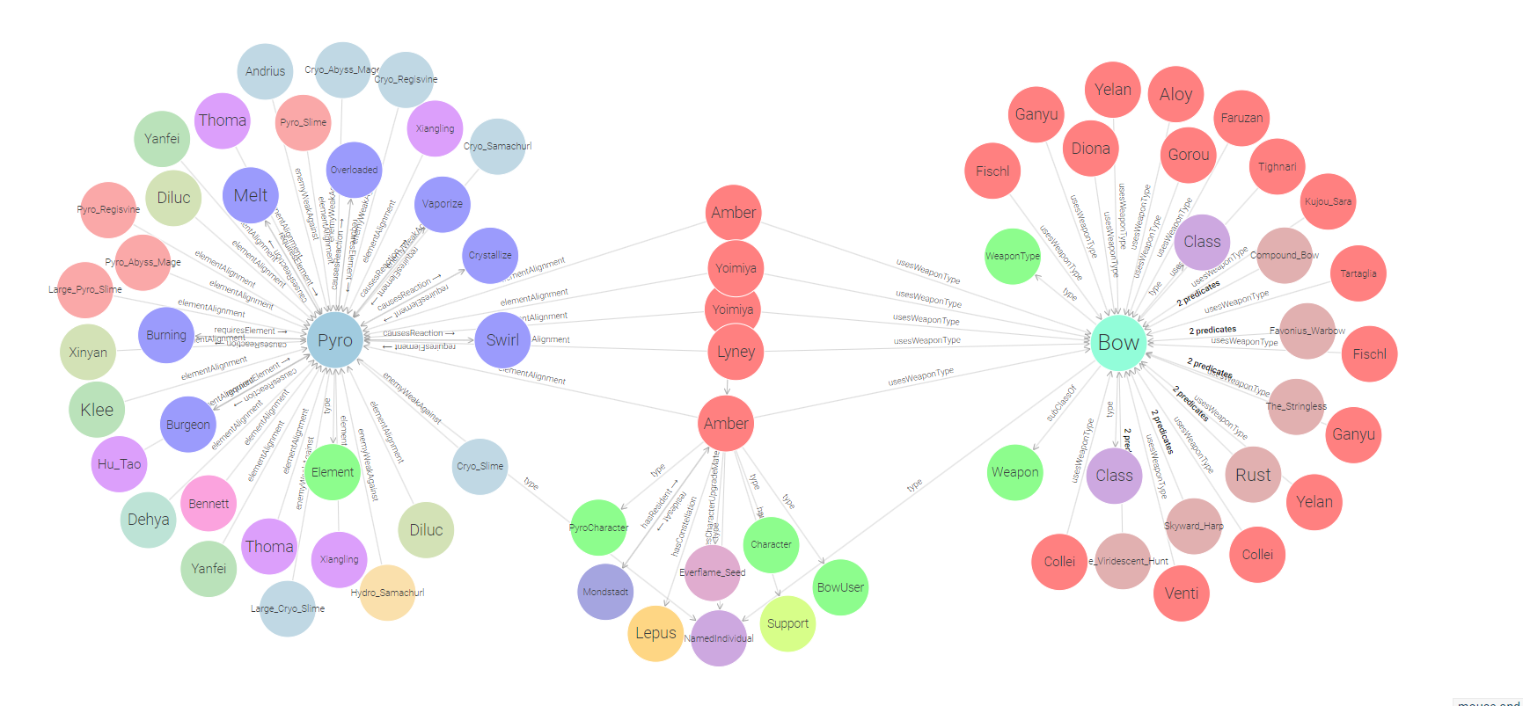

Over here, we can see Amber, Yoimiya and Lyney being Bow character who have a Pyro vision/

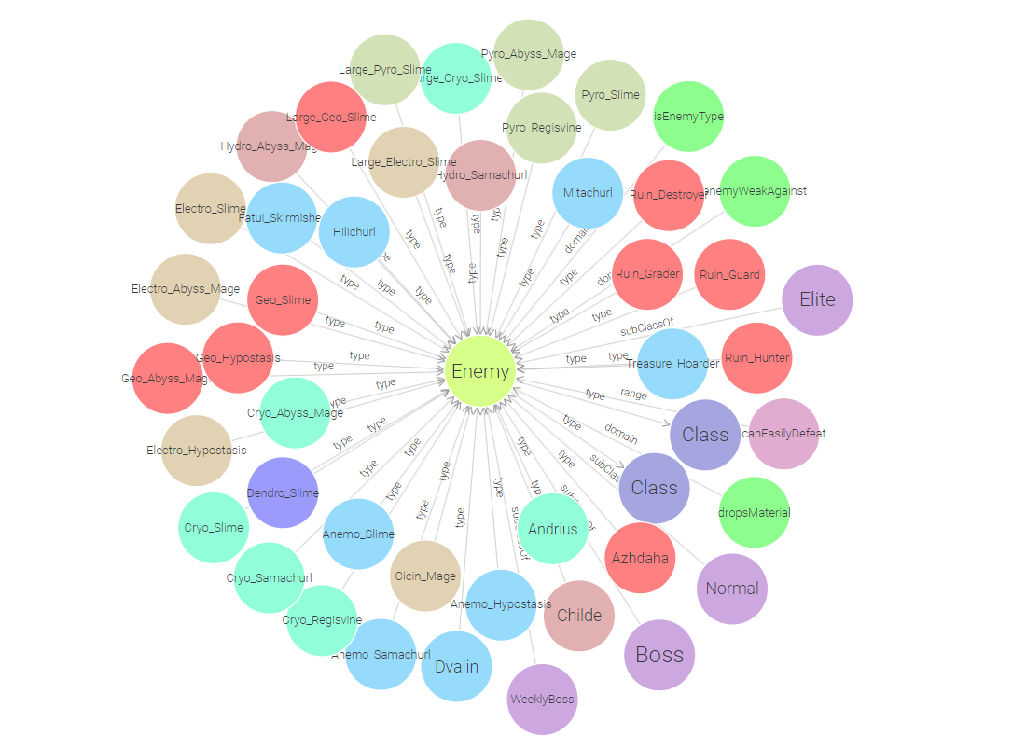

Here we can see the individuals related to Enemy class, the subclasses and domain/ranges for object properties where Enemy class is used in

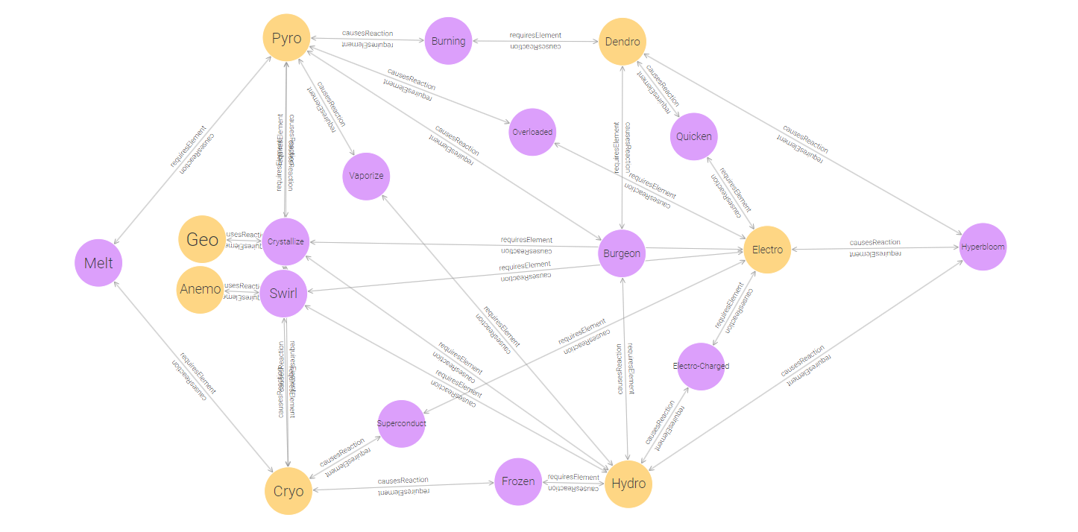

These are the relations between Elements and Reactions

# **Reflect**

This was honestly a fun project with a lot of learning involved. Perhaps the most important thing we learned was how to properly represent data in a meaningful way. There were a lot of times and a lot of wasted hours where we had to redesign our ontology because the relations we tried to achieve between individuals just weren’t making any sense. But at the end, we managed to create a pretty accurate representation of how the game works in the form of a graph.

Converting unstructured data like this to linked data (especially when SWRL rules were used) did have a lot of benefits. Whenever we played the game and a new boss/weekly boss would come out, we would try to figure out which characters would be good against it and whenever a new character was added, we would try to figure out new teams we could make using that character. Thanks to the inferencing power of SWRL rules and OWL itself -we were able to automate this questions and stored all of the direct information necessary to answer it in our graph :).

Overall there is still a lot left in this game’s graph development. If we can create a 1 to 1 model of the game using these technologies then theorycrafting team combinations and finding the most optimal teams to beat spiral abyss would be just automated within these graphs. In the future, I’ll probably revisit this a few more times, (I’ll need to convert this to an LPG first though) because this was more of a passion project than a project being done for a course.

Thank you so much for allowing our team to choose this topic, I know you must have been a bit worried because we even mentioned in the beginning that we have 0 tabular data to work on this project idea but when there’s creative freedom given, there will always be a way.

Farewell